*Florida International University*

*School of Computing and Information Sciences*

Software Engineering Focus

Final Deliverable

Augmented Reality:

OOP Concepts using Hololens

**Team Member(s):** *Paola Jiron and Andres Chalela*

**Product Owner(s)**: *Francisco Ortega*

**Mentor(s)**: *Francisco Ortega*

**Instructor(s)**: *Masoud Sadjadi and Mohsen Taheri*

The MIT License (MIT)

Copyright (c) *2016 Florida International University*

Permission is hereby granted, free of charge, to any person obtaining a copy of this software and associated documentation files (the "Software"), to deal in the Software without restriction, including without limitation the rights to use, copy, modify, merge, publish, distribute, sublicense, and/or sell copies of the Software, and to permit persons to whom the Software is furnished to do so, subject to the following conditions:

The above copyright notice and this permission notice shall be included in all copies or substantial portions of the Software.

THE SOFTWARE IS PROVIDED "AS IS", WITHOUT WARRANTY OF ANY KIND, EXPRESS OR IMPLIED, INCLUDING BUT NOT LIMITED TO THE WARRANTIES OF MERCHANTABILITY, FITNESS FOR A PARTICULAR PURPOSE AND NONINFRINGEMENT. IN NO EVENT SHALL THE AUTHORS OR COPYRIGHT HOLDERS BE LIABLE FOR ANY CLAIM, DAMAGES OR OTHER LIABILITY, WHETHER IN AN ACTION OF CONTRACT, TORT OR OTHERWISE, ARISING FROM, OUT OF OR IN CONNECTION WITH THE SOFTWARE OR THE USE OR OTHER DEALINGS IN THE SOFTWARE.

***Abstract***

*This document presents the information necessary to gain a good understanding of Augmented Reality (AR). AR is integrated via the implementation of Object Oriented Programming (OOP) concepts using the Hololens device. Due to the 3-Dimensional application of AR, objects are visually represented in 3D space which can be seen while wearing the Hololens device. Basic understanding of Object Oriented concepts is not necessary, as this project is subject to educational research on Computer Science concepts.*

**Table of Contents**

**Introduction**

Current System ………………………………………………………………………………………...5

Purpose of New System ..………………………………………………………………………………5

**User Stories**

Implemented User Stories .…………………………………………….………………………………6

Pending User Stories ………………………………………………………………………………...14

**Project Plan**

Hardware and Software Resources ……………………………………………………………....16

Sprints Plan …………………………………………………………………………………………..19

*Sprint 1* ………………………………………………………………………………………………..19

*Sprint 2*  ………………………………………………………………………………………………. 20

*Sprint 3*  ……………………………………………………………………………………………….21

*Sprint 4*  ………………………………………………………………………………………………..22

*Sprint 5*  ……………………………………………………………………………………………….24

*Sprint 6*  ……………………………………………………………………………………………….26

*Sprint 7*  ……………………………………………………………………………………………….28

**System Design**

Architectural Patterns ……………………………………………………………………….…….29

System and Subsystem Decomposition……………………………………………………………….30

Deployment Diagram ………………………………………………………………………….…….30

Design Patterns ………………………………………………………………………………..…….31

**System Validation**  ……………………………………………………………………………………..32

**Glossary**  …………………………………………………………………………………………………55

**Appendix**

Appendix A - UML Diagrams ……………………………………………….…………………….……58

*Class Diagram*  ……...…………………………………………………….………………….………58

*Finite State Machine*  ……………………………………………………….…………………………61

Appendix B - Interaction Viewpoint ……………………………………….………………………...62

Appendix C - User Interface Design ……………………………………….………………………...83

Appendix D - Sprint Review Reports .……………………………………….…………………… …..90

Appendix E - User Manuals & Installation/Maintenance Document …….……….……………….97

**Research** ...……………………………………………………………………………………………..102

**References**

Application Development References …………………………………………………………..109

Research References………………………………………………………………………………111

# Introduction

To integrate the concept of Augmented Reality in Computer Science it is required to have access to a Hololens device. After gaining access to a Hololens device, the intermediate to advance understanding of Object Oriented Programming concepts is suggested to able to develop a functional yet adequate application. Users on the other hand, do not require such background knowledge since this application is subject to research. The following material provides thorough information of the benefits and learning curves that Augmented Reality aggregates within technology through both Computer Science and Engineering concepts. This document is part of an ongoing research. The use of interactive learning has proven to raise the interest in individuals lacking fundamental understanding of Object Oriented Programming concepts and to the Computer Science industry.

## 

## Current System

Although it is an ongoing research on Augmented Reality, there is currently no existing system integrated. The material covered beyond this point is the initial programming integration of the research.

## Purpose of New System

The purpose of this system is to enable different venues of teaching and reaching out to students on the Computer Science path to a different teaching approach of OOP concepts. It has been proven through research that students in Computer Science are missing a profound understanding of OOP material like identifying variables, decision making, looping, and personally describing the concept of objects and data structures. Due to the missing fundamental understanding of said concepts, the such automates a disconnection between student and professor. Ergo making it even more challenging for professors to teach the material and difficult for the student to grasp new information.

# User Stories

The following section provides the detailed user stories that were implemented in this iteration of the OOP Concepts with Augmented Reality Using Hololens project. These user stories served as the basis for the implementation of the project’s features. This section also shows the user stories that are to be considered for future development.

## Implemented User Stories

* US1147: Set-up Needed Software for HoloLens Dev.

Description:

*As a developer for the HoloLens using Mac OSX, I have to install a VM and install all the required programs for HoloLens Development, so that programming within the Unity 3D environment can be performed without difficulties.*

Acceptance Criteria:

1. Mac OSX is partitioned correctly with Boot Camp to run Windows 10 OS.
2. Visual Studio is installed correctly and is able to run HoloLens emulator.
3. Unity is installed correctly and is integrated with Visual Studio.

* US1148: Receive Access to HoloLens Hardware

Description:

*As a developer, I have to get access to HoloLens hardware, so that I can familiarize myself with the platform and the utilize the capabilities that are available.*

Acceptance Criteria:

1. I have access to and have understand how to operate HoloLens device.
2. I have understanding of gestures and features that are available during development.
3. I have understanding how to operate and utilize HoloLens Emulator

* US1149: Access to Hololens Device and Learning Scrum Methodologies

Description:

*As a developer, I need to know how to implement and work with 3D objects in Unity/Visual Studio, so that I can utilize AR capabilities and have a solid foundation of how to work with virtual objects*

Acceptance Criteria:

1. Be able to create an object (i.e: sphere, square, triangle...) within Unity platform
2. Be able to import created object to HoloLens platform
3. Be able to manipulate object size, color, placement

* US1150: Access to Hololens Device and Learning Scrum Methodologies

Description:

*As a Hololens developer I must understand scrum methodology and how to use mingle software so that I can apply these to Hololens applications development*

Acceptance Criteria:

1. Watch tutorials on Scrum methodologies
2. Watch tutorials on Mingle
3. Install Visual Studio and Unity
4. Get access to the Hololens
5. Get acquainted with the Hololens
6. Connect the Hololens to the computer

* US1151: User Interaction

Description:

*As a user I want to interact with the Hololens using hand gestures so that the system can understand commands.*

Acceptance Criteria:

1. Gesture recognition
2. Use clicker to substitute hand gesture recognition
3. Use voice command to substitute clicker and/or hand gesture recognition

* US1152: User Interface and Creating Objects

Description:

*As a user I want to manipulate objects in 3D space using object oriented programming so that I get exposure to an interactive and virtual representation of programming concepts.*

Acceptance Criteria:

1. Follow and read documentation on how to create and manipulate objects and their attributes in Unity
2. Create an object
3. Integrate gesture recognition
4. Create a boundary area or plane to simulate a room
5. Integrate colours and movement/speed
6. Test the aspect view of the camera, which should be aligned to the players perspective
7. Have the camera/view go along with the player’s view

* US1188: Implement Gesture Scripts on Unity

Description:

*As a HoloLens Developer, I need to be able to implement HoloLens gesture scripts within Unity projects, to be able to create HoloLens apps that use hand gestures as input*

Acceptance Criteria:

1. Create Unity project that uses scripts that allow hand gestures as input on HoloLens platform
2. Use hand gestures to affect input within created Unity HoloLens app
3. Use hand gestures to successfully launch & close created HoloLens app

* US1190: Implement Gaze Scripts on Unity

Description:

*As a developer, I have to be able to implement HoloLens Gaze scripts on Unity, so that Gaze input capabilities are functional within created Unity HoloLens apps.*

Acceptance Criteria:

1. Gaze scripts have been implemented within created Unity HoloLens projects.
2. Able to use Gaze functionality within launched HoloLens app.

* US1191: Implement Voice Scripts on Unity

Description:

*As a developer, I need to know how to implement voice scripts on Unity, so that voice commands are available within created Unity HoloLens project.*

Acceptance Criteria:

1. User can use their voice to manipulate a functionality within created Unity app.

* US1205: Gaze, Gesture, and Voice Recognition

Description:

*As a user I would like to control objects with my gaze, hand gestures, or voice so that it gives me flexibility over the use of the HoloLens device in case I am either visually impaired, mute, or both (i.e. aiming for people with Disabilities)*

Acceptance Criteria:

1. Enable and create functionality for Gaze recognition using the doughnut cursor
2. Enable and create functionality for hand Gestures using the doughnut cursor to focus on an object
3. Enable and create functionality for Voice recognition using the doughnut focus on an object and programmer integrated commands.
4. Add sound features as the objects come in touch with other objects.
5. Download HoloLens Application to enable screen mirroring feature. This will enable the programmer to see what the user sees on the device while wearing it.

* US1154: Object Variables

Description:

*As a user I want to be able to use gestures and gaze on visual representations of variables so that I know where my gaze is and make a selection on the 3D environment.*

Acceptance Criteria:

1. Apply lessons learned from tutorials to create the application from now on.
2. Create 3D visual representation of a variable.
3. Create multiple 3D visual representation choices for a variable.
4. Setup the camera to focus on all objects upon initiating the game.
5. Add color or texture.
6. Add background music to set the playing mood.
7. Loop the background music.
8. Add movement to the visual objects.
9. Apply Gaze cursor.
10. Test
11. Deploy and build on Emulator
12. Deploy and build on Hololens device

* US1238: Visualization of Variables w/in HoloLens App

Description:

*As a user, I need to be able to manipulate a variable attribute of an object, so that I can visualize and understand the purpose and functionality of variables within Object Oriented Programming.*

Acceptance Criteria:

1. User see’s floating color palette element and when app is launched
2. User can manipulate the color attribute of an UI element within HoloLens App by using gesture inputs to select specific color

* US1239: Scenes

Description:

*As a user, I would like to move through scenes as I progress through the 3D application so that I can focus on one scene at a time.*

Acceptance Criteria:

1. Implement main scene with Play, and Exit game buttons.
2. Do not add a back button.
3. Test.
4. Deploy and Build on Hololens emulator.
5. Debug.
6. Deploy and Build project on Hololens device.

* US1153: Methods

Description:

*As a user I would like to see a visualization of methods and functions so that I can better understand the characteristics of methods.*

Acceptance Criteria:

1. Create 4 objects which have a particular yet different functionality.
2. Add gaze and gesture to select and identify an object.
3. Test: Build, Deploy, and Run on device and emulator.

* US1155: Data Structures

Description:

*As a user I want to view visual representations of data structure concepts so that I can better understand data structure concepts.*

Acceptance Criteria:

1. Create objects that represent: Arrays, Linked Lists, Stacks, and Queues.
2. Add gaze and gesture recognition to the four objects.
3. Test: Build, Deploy, and Run on device and emulator.

* US1281: Scene Transition

Description:

*As a user I would like to be able to move through scenes after making my selection so that I am progressing through the application.*

Acceptance Criteria:

1. Add a “Next” button on each scene besides the main scene which has a “Start” and “Exit” buttons.
2. Add gaze and gesture recognition.
3. Add a collider.
4. If no collider is available for UI elements, add an object without a mesh to enable cursor on collision features.
5. Test.
6. Deploy.
7. Run.

* US1282: Credits

Description:

*As a user I would like to have access to a contact and information about the application section so that I can contact the developers for further information.*

Acceptance Criteria:

1. Create a new empty scene.
2. Add a canvas to the scene.
3. Add text element from the UI features.
4. Add Developer/Student, Mentor, and Instructor information.
5. Add a Back button.
6. Add a Credits button on the Main scene (Scene 1).
7. Add gaze, cursor and gesture recognition.
8. Test: Build, Deploy, and Run on device and emulator.

* US1304: Visualization of Object Accessor/Mutator Methods

Description:

*As a user, I have to be able to manipulate a holographic object’s color variable attribute, so that I can have a visualization of what object accessor/mutator methods are and how they function.*

Acceptance Criteria:

1. Display UI prompt for user to know what the purpose of holographic exercise is for.
2. Display Color Palette for User to Manipulate Holographic Object Color
3. User can tap on color palette to access the 3D object’s color attribute and set it to the respective chosen color

## Pending User Stories

* Voice Recognition

Description:

*As a user I would like to speak up my interaction with the application in the case that I am physically unable to use gestures so that other users with physical disabilities can experience the joy of interactive learning.*

Acceptance Criteria:

1. Add voice command on selection script. The command is recognized under the OnSelect function.
2. Modify the other manager if needed.
3. Test. Build. Deploy.
4. Run on Hololens device.

* Code optimization to improve runtime

Description:

*As a developer I would like to merge all redundant (repeated) code into one manager/controller script so that the application runs smoother and less lag.*

1. Improve by merging all scene transition scripts into one transition manager script.
2. One approach is to create an array of the scenes and traverse the list of scenes after the user makes a selection and clicks the NEXT button.
3. Reduce runtime from O(${n^{2}}^{}$) to O($n$) or better.
4. Test. Build. Deploy.
5. Run on Hololens device.

* Enable multiple answer selection

Description:

*As a user I would like to have the ability to make more than one selection to a question so that I can give a complete answer in case the question has more than one answer.*

1. Create a function or script to handle multiple user selections.
2. One approach is to create a collection of objects and traverse these when displaying results in the results scene.
3. Test. Build. Deploy.
4. Run on Hololens device.

* Expand Questionnaire

Description:

*As a user I would like to have many other questions on object oriented programming concepts so that I can view many 3D models of the concepts with tutorials.*

1. Create more scenes with separate OOP concepts.
2. Create tutorials for additional scene concepts in the same format as existing tutorials.
3. Add functionalities and scripts to the new scenes.
4. Test. Build. Deploy.
5. Run on the Hololens device.

# Project Plan

This section describes the planning that went into the realization of this project. This project incorporated the agile development techniques and as such required the sprints to be planned. The process of these sprints are detailed in this section. This section also describes the components, both software and hardware, chosen for this project.

## Hardware and Software Resources

The following is a list of all hardware and software resources that were used in this project:

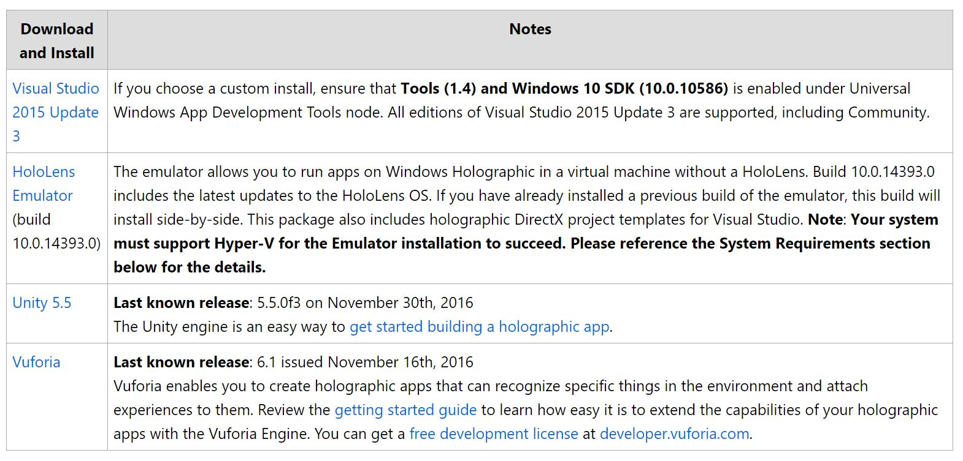

**i) Visual Studios 2015 Update 3**

Client Operating Systems

* Windows 10 (Home, Professional, Enterprise)
* Windows 8.1 (Basic, Professional, Enterprise)
* Windows 7 (minimum SP1) (Home Premium, Professional, Enterprise, Ultimate)

**ii) Emulator**

The HoloLens emulator is based on Hyper-V and uses RemoteFx for hardware accelerated graphics. To use the emulator, make sure your PC meets these hardware requirements:

* 64-bit Windows 10 Pro, Enterprise, or Education (The Home edition does not support Hyper-V or the HoloLens emulator)
* 64-bit CPU
* CPU with 4 cores (or multiple CPU's with a total of 4 cores)
* 8 GB of RAM or more
* In the BIOS, the following features must be [supported and enabled](http://blogs.technet.com/b/iftekhar/archive/2010/08/09/enable-hardware-settings-in-bios-to-run-hyper-v.aspx):
  + Hardware-assisted virtualization
  + Second Level Address Translation (SLAT)
  + Hardware-based Data Execution Prevention (DEP)
* GPU (The emulator might work with an unsupported GPU, but will be significantly slower)
  + DirectX 11.0 or later
  + WDDM 1.2 driver or later

If your system meets the above requirements, please ensure that the "Hyper-V" feature has been enabled on your system through Control Panel -> Programs -> Programs and Features -> Turn Windows Features on or off -> ensure that "Hyper-V" is selected for the Emulator installation to be successful.

**iii) Hololens Device**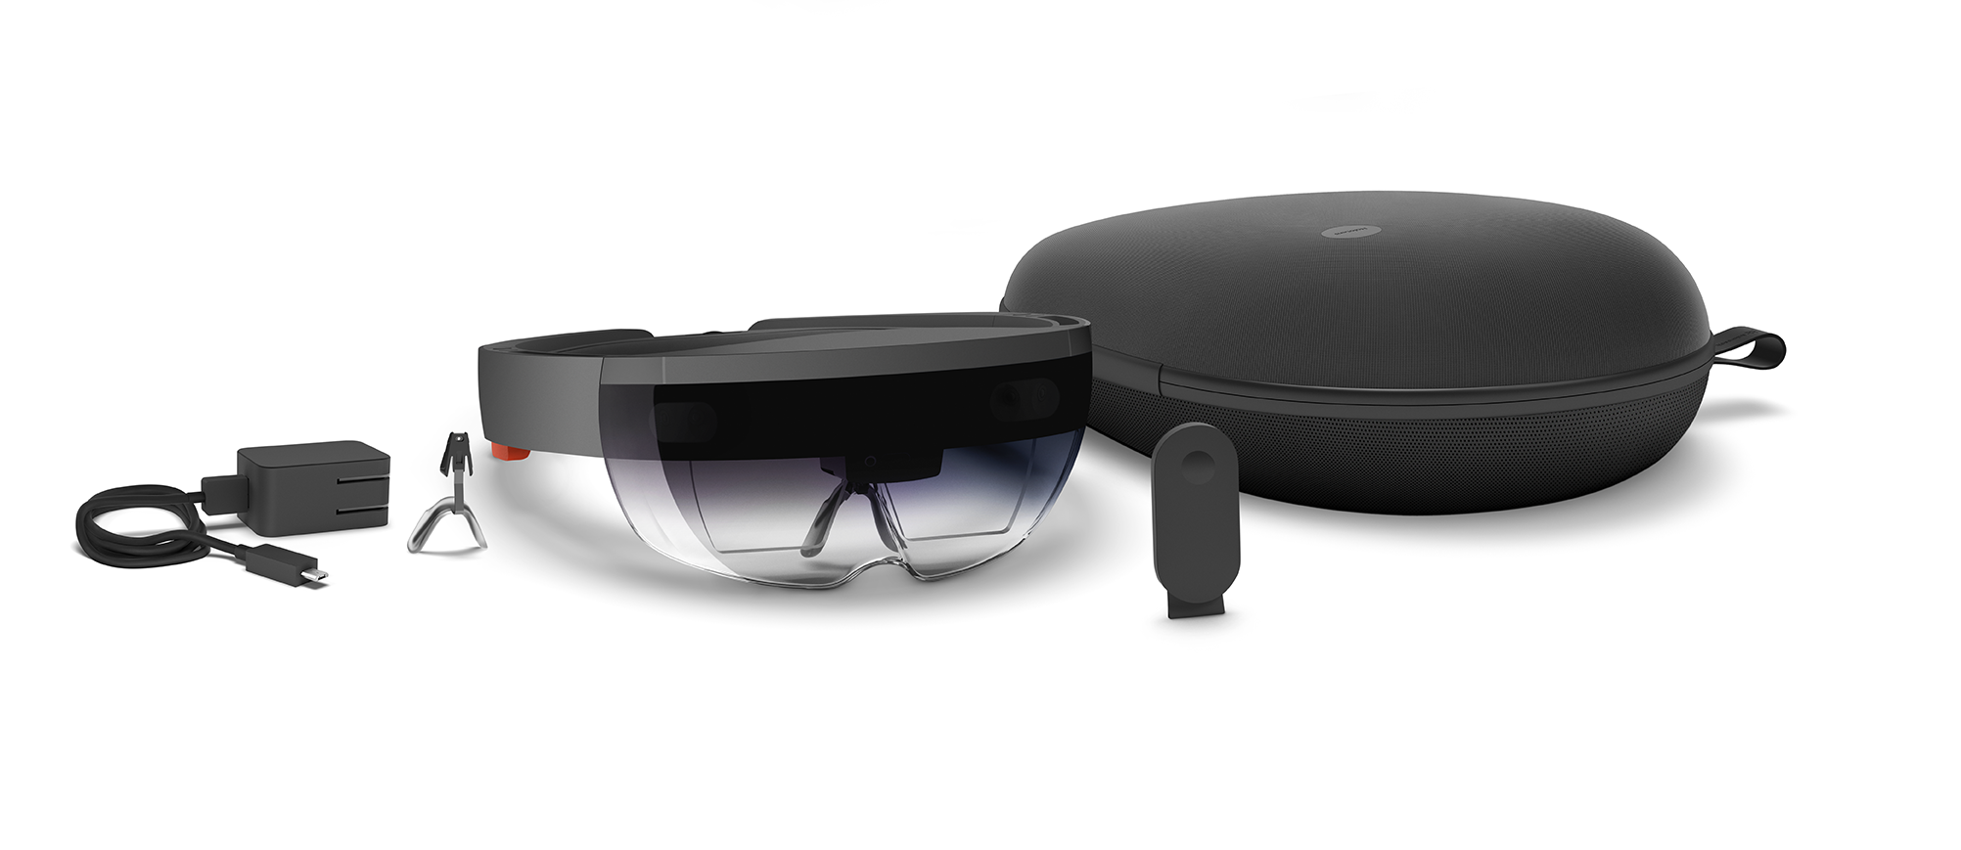

**iv) Microsoft Hololens Application**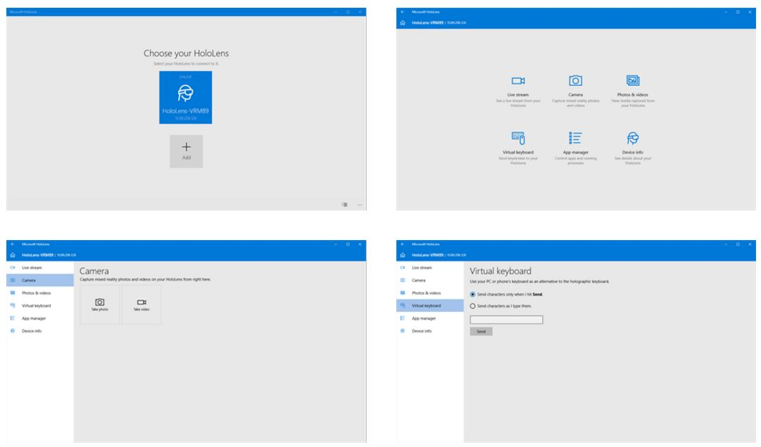

This application is provided on the Microsoft App Store for free. It enables the pairing with the Microsoft Hololens Development Edition and it is used to view a live stream from the device's point of view, remotely start and stop applications, capture mixed reality photos and videos, and so on.

## Sprints Plan

### Sprint 1

**Sprint Planning Meeting Minutes:**

Attendees: Andres Chalela, Paola Jiron

Date: 01/15/17

Start time: 3:00PM

End time: 6:00PM

After discussion, the velocity of the team were estimated to be:

20 hrs per week for senior project students, and 10 hrs per week for VIP students.

The product owner chose the following user stories to be done during the next sprint. They are ordered based on their priority.

* User Story: *User stories yet to be determined. Product owner wanted us to get familiar with the software and read tutorials.*

The team members indicated their willingness to work on the following user stories.

* Andres Chalela
* User Story: None for this week. Focused on topic ideas for project and setting up needed software/hardware.
* Paola Jiron
* User Story: *Negligible this week. Focused on reading on Unity, Scrum, Agile, Hololens implementations, and Mingle. Also watch last semester's senior project videos.*

### Sprint 2

**Sprint Planning Meeting Minutes:**

Attendees: Andres Chalela, Paola Jiron

Date: 02/05/17

Start time: 5:00PM

End time: 7:00PM

After discussion, the velocity of the team were estimated to be:

20 hrs per week for senior project students, and 10 hrs per week for VIP students.

The product owner chose the following user stories to be done during the next sprint. They are ordered based on their priority.

* User Story: *No particular order.*

The team members indicated their willingness to work on the following user stories.

* Andres Chalela:

*#1149 Implementation & Manipulation of 3D/Virtual Objects*

As a developer, I need to know how to implement and work with 3D objects in Unity/Visual Studio, so that I can utilize AR capabilities and have a solid foundation of how to work with virtual objects

* Paola Jiron:

*#1152 Hololens User Interface/Creating Objects*

As a user I want to manipulate objects in 3D space using object oriented programming so that I get exposure to an interactive and virtual representation of programming concepts.

### Sprint 3

**Sprint Planning Meeting Minutes:**

Attendees: Andres Chalela, Paola Jiron

Date: 02/25/17

Start time: 5:00PM

End time: 7:00PM

After discussion, the velocity of the team were estimated to be:

20 hrs per week for senior project students, and 10 hrs per week for VIP students.

The product owner chose the following user stories to be done during the next sprint. They are ordered based on their priority.

* User Story: *No particular order.*

The team members indicated their willingness to work on the following user stories.

* Andres Chalela:

*#1190 Implementation Gaze Scripts on Unity*

As a developer, I have to be able to implement HoloLens Gaze scripts on Unity, so that Gaze input capabilities are functional within created Unity HoloLens apps.

* Paola Jiron:

*#1205 Gaze, Gesture, & Voice Recognition*

As a user I would like to control objects with my gaze, hand gestures, or voice so that it gives me flexibility over the use of the HoloLens device in case I am either visually impaired, mute, or both (i.e. aiming for people with Disabilities)

### Sprint 4

**Sprint Planning Meeting Minutes:**

Attendees: Andres Chalela, Paola Jiron

Date: 03/10/17

Start time: 5:00PM

End time: 7:00PM

After discussion, the velocity of the team were estimated to be:

20 hrs per week for senior project students, and 10 hrs per week for VIP students.

The product owner chose the following user stories to be done during the next sprint. They are ordered based on their priority.

* User Story: *No particular order.*

The team members indicated their willingness to work on the following user stories.

* Andres Chalela:

[*#1238*](https://fiu-scis-seniorproject.mingle.thoughtworks.com/projects/mult_touch_midair_and_motion_f/cards/1238) *(HoloLens) Visualization of Variables w/in HoloLens App*

As a user, I need to be able to manipulate a variable attribute of an object, so that I can visualize and understand the purpose and functionality of variables within Object Oriented Programming.

*#1190 Implementation VoiceScripts on Unity*

As a developer, I need to know how to implement voice scripts on Unity, so that voice commands are available within created Unity HoloLens project..

* Paola Jiron:

*#1154 Object Variables*

As a user I want to be able to use gestures and gaze on visual representations of variables so that I know where my gaze is to actively interact 3D environment.

*#1239 Scenes*

As a user, I would like to move through scenes as I progress through the 3D application so that I can focus on one scene at a time.

### Sprint 5

### 

**Sprint Planning Meeting Minutes:**

Attendees: Andres Chalela, Paola Jiron

Date: 03/24/17

Start time: 5:00PM

End time: 7:00PM

After discussion, the velocity of the team were estimated to be:

20 hrs per week for senior project students, and 10 hrs per week for VIP students.

The product owner chose the following user stories to be done during the next sprint. They are ordered based on their priority.

* User Story: *No particular order.*

The team members indicated their willingness to work on the following user stories.

* Andres Chalela:

*#1189 (HoloLens) AR/VR - Research*

As a researcher, I have to search for potential themes/ideas on AR & Education, so that I can finalize a topic and begin work on research paper.

*#1304 (HoloLens) Visualization of Object Accessor/Mutator Methods*

*As a user, I have to be able to be able to manipulate a holographic object’s color variable attribute, so that I can have a visualization of what object accessor/mutator methods are and how they function.*

* Paola Jiron:

*#1153 Methods*

As a user I would like to see a visualization of methods and functions so that I can better understand the characteristics of methods.

*#1155 Data Structures*

As a user I want to view visual representations of data structure concepts so that I can better understand data structure concepts.

*#1281 Scene Transition*

As a user I would like to be able to move through scenes after making my selection so that I am progressing through the application.

### 

### Sprint 6

**Sprint Planning Meeting Minutes:**

Attendees: Andres Chalela, Paola Jiron

Date: 04/07/17

Start time: 5:00PM

End time: 7:00PM

After discussion, the velocity of the team were estimated to be:

20 hrs per week for senior project students, and 10 hrs per week for VIP students.

The product owner chose the following user stories to be done during the next sprint. They are ordered based on their priority.

* User Story: *No particular order.*

The team members indicated their willingness to work on the following user stories.

* Andres Chalela:

[*#1*](https://fiu-scis-seniorproject.mingle.thoughtworks.com/projects/mult_touch_midair_and_motion_f/cards/1238)*307 AR/VR Research Paper Introduction*

As a researcher, I have to use the selected research source material to develop and finalize an introduction, so that I have a clear direction in which I plan to structure the ideas for my semester paper

*#1308 Finalization of AR/VR Research Paper*

As a researcher, I have to compete and finalize remaining sections of research paper, so that the final draft can be formatted properly and proof-read before the final submission deadline.

* Paola Jiron:

*#1156 Tutorial*

As a user I would like to view a tutorial about the game so that I can see the relation between the game and actual programming concepts.

*#1157 Feedback and Progress*

As a user I want to receive feedback so that I can track my progress in the OOP Concept AR application.

### Sprint 7

**Sprint Planning Meeting Minutes:**

Attendees: Andres Chalela, Paola Jiron

Date: 04/21/17

Start time: 5:00PM

End time: 7:00PM

After discussion, the velocity of the team were estimated to be:

20 hrs per week for senior project students, and 10 hrs per week for VIP students.

The product owner chose the following user stories to be done during the next sprint. They are ordered based on their priority.

* User Story: *No User Stories for this sprint. We met up to finalize documents and demos.*

# System Design

This section contains information on the design decisions that went into this project. The architecture patterns are outlined and explained. The entire system is shown in a package diagram and the subsystems are explained. Finally, the design patterns used in the project are discussed.

## Architectural Patterns

OOP3D acquires a Model View Controller (MVC) system architecture style. The model subsystem contains user interaction knowledge with the View focusing solely on the user interface for both developer and player actors. The controller is basically a manager split in three sub-managers: Gaze, Gesture, and Voice managers. There are Rotator and Sound managers setup to add animation to the objects on every scene and a soundtrack that plays in a loop throughout the life of the application until the user decides to quit. A package diagram presents an overview of the major subsystems of the OOP3D application.

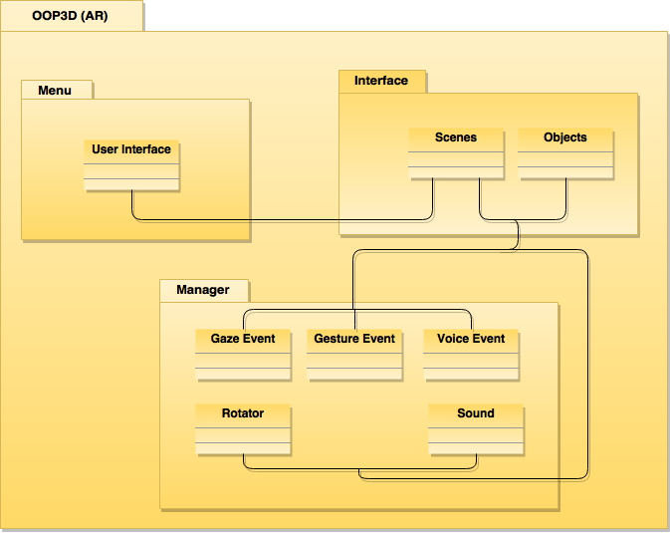

## 

## 

## System and Subsystem Decomposition

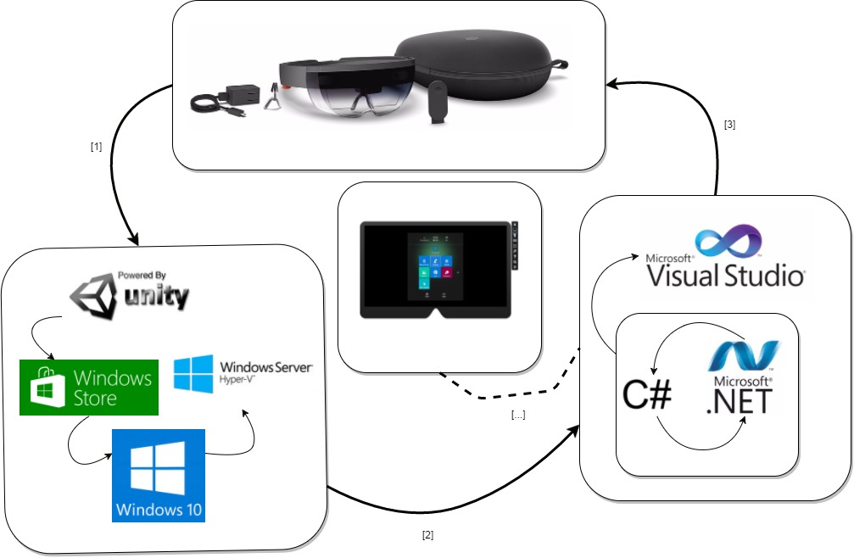

## Deployment Diagram

Developing a Microsoft Hololens application requires four major steps: Creation, Conversion, Building, and Deployment. To develop it is normally necessary to use Blender to seamlessly create objects. Blender enables a better user experience due to the mesh by which objects are composed. The scenery is required and normally implemented in the Unity environment accompanying the objects with other features and components. Nonetheless, to enable user interactivity and functionality it is necessary to either program these in JavaScript or C#. C# is more user friendly and it comes in handy when working with objects being that C# is an object oriented programming language, similar to Java. C# and JavaScript scripts can be written in several IDEs, but due to the .NET framework by which Hololens applications encompass it is necessary to use the Visual Studio library. Visual Studio has the capacity and is the only IDE that can acquire the Microsoft Hololens Emulator and can also connect directly to the Hololens device to build and deploy holographic applications.

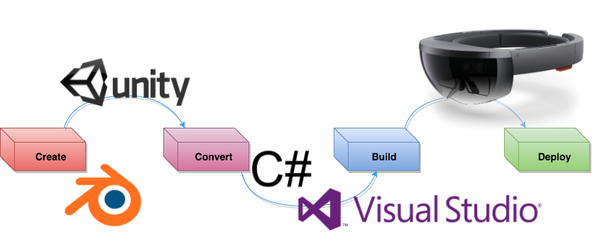

## 

## Design Patterns

OOP3D is built in forms of scenes, of which are implemented separately and connected solely on scripts via user interaction during play mode. The first scene the user sees upon starting the game application is the Menu scene. This scene contains four buttons: Start, Exit, Credits, and Tutorials.

1. The Exit button terminates the application.
2. The Credits button displays the contact information of the developer and contributors of the application.
3. The Start button follows three scenes: Variables, Methods, and Data Structures scenes respectively which include a question and four objects, that are the optional responses to that question. After each response, the user has the choice to either answer, or move to the next scene without responding. This is done by clicking the NEXT button at the bottom right corner of each scene. The final scene before returning home (back to the Menu scene) displays the results and a HOME button at the bottom right corner of the scene. The Results scene contains the user's answers and the correct answers. When a user selects an object as their response to each question, the object increases in size to give feedback.
4. The Tutorials button follows six scenes with thorough tutorials on: Variables, Methods, Arrays, Stacks, Queues, and Linked Lists respectively. Each tutorial scene contains a NEXT button leading to the following tutorial. Every tutorial has the following information: facts and concepts, syntax, code examples, and editorials.

# System Validation

The application is implemented with two actors in mind: the player and the developer. Both actors have everything, but one thing in common. Both player and developer can start a game session, view the tutorials, credits, and quit the application. The developer is the only actor that can access developer mode and modify the game application.

# 

**Use Cases**

Use Case ID: US1154-1

1. Name: Start game
2. Actor: Player, Developer
3. Pre-conditions: Actor has initialized the game application
4. Post-condition: Actor manipulates cursor with Gaze and head movements
5. Flow of events:

|  |  |
| --- | --- |
| 1. Actor gazes at the "Start" button. |  |
|  | 2. Actor controls cursor with head movements. |
| 3. When the cursor shows up on the "Start" button. Hold gaze. |  |
|  | 4. Actor speaks the "Select" command or finger taps to start the game. |

Use Case ID: US1154-2

1. Name: Exit game
2. Actor: Player, Developer
3. Pre-conditions: Application is running and actor is wearing the Hololens device
4. Post-condition: Actor has initialized the game application
5. Flow of events:

|  |  |
| --- | --- |
| 1. Actor gazes at the "Exit" button. |  |
|  | 2. Actor controls cursor with head movements. |
| 3. When the cursor shows up on the "Exit" button. Hold gaze. |  |
|  | 4. Actor speaks the "Select" command or finger taps to exit the game. |

Use Case ID: US1154-3

1. Name: View game credits
2. Actor: Player, Developer
3. Pre-conditions: Application is running and actor is wearing the Hololens device
4. Post-condition: Actor has initialized the game application
5. Flow of events:

|  |  |
| --- | --- |
| 1. Actor gazes at the "Credits" button. |  |
|  | 2. Actor controls cursor with head movements. |
| 3. When the cursor shows up on the "Credits" button. Hold gaze. |  |
|  | 4. Actor speaks the "Select" command or finger taps to access credits. |

Use Case ID: US1205-1

1. Name: Move cursor with your Gaze
2. Actor: Player, Developer
3. Pre-conditions: Actor has initialized the game application
4. Post-condition: Actor manipulates cursor with Gaze and head movements
5. Flow of events:

|  |  |
| --- | --- |
| 1. Actor gazes at an object. |  |
|  | 2. Actor controls cursor with head movements. |
| 3. When the cursor shows up on the object of choice. Hold gaze. |  |
|  | 4. Object is ready for interaction. |

Use Case ID: US1205-2

1. Name: Gesture Recognition
2. Actor: Player, Developer
3. Pre-conditions: Application is running and actor is wearing the Hololens device
4. Post-condition: Actor has initialized the game application
5. Flow of events:

|  |  |
| --- | --- |
| 1. Actor gazes at an object. |  |
|  | 2. Actor controls cursor with head movements. |
| 3. When the cursor shows up on the object of choice. Hold gaze. |  |
|  | 4. Actor taps object with finger. |

Use Case ID: US1153-1

1. Name: View Methods
2. Actor: Player, Developer
3. Pre-conditions: Actor has finished interacting with the Variable scene. Actor is currently in the Variables scene.
4. Post-condition: Actor selects the "NEXT" button with gaze and gestures. Actor is now in the Methods scene.
5. Flow of events:

|  |  |
| --- | --- |
| 1. Actor is in the Variables scene. |  |
|  | 2. Actor gazes at the "Next" button. |
| 3. When the cursor shows up on the "NEXT" button. Hold gaze. |  |
|  | 4. Actor finger taps the button to move to the Methods scene. |
| 5. Actor is now in the Methods scene. |  |

Use Case ID: US1155-1

1. Name: View Data Structures
2. Actor: Player, Developer
3. Pre-conditions: Actor has finished interacting with the Methods scene. Actor is currently in the Methods scene.
4. Post-condition: Actor selects the "NEXT" button with gaze and gestures. Actor is now in the Data Structures scene.
5. Flow of events:

|  |  |
| --- | --- |
| 1. Actor is in the Methods scene. |  |
|  | 2. Actor gazes at the "Next" button. |
| 3. When the cursor shows up on the "NEXT" button. Hold gaze. |  |
|  | 4. Actor finger taps the button to move to the Data Structures scene. |
| 5. Actor is now in the Data Structures scene. |  |

Use Case ID: US1282-1

1. Name: View game credits
2. Actor: Player, Developer
3. Pre-conditions: Application is running and actor is wearing the Hololens device
4. Post-condition: Actor has left the Main scene and is now viewing the Credits scene.
5. Flow of events:

|  |  |
| --- | --- |
| 1. Actor gazes at the "Credits" button. |  |
|  | 2. Actor controls cursor with head movements. |
| 3. When the cursor shows up on the "Credits" button. Hold gaze. |  |
|  | 4. Actor speaks the "Select" command or finger taps to access credits. |
| 5. Actor is now in the Credits scene. |  |

Use Case ID: US1282-2

1. Name: Leave Credits scene and go back to Main scene.
2. Actor: Player, Developer
3. Pre-conditions: Application is running and actor is wearing the Hololens device
4. Post-condition: Actor has left the Credits scene and is now viewing the Main scene.
5. Flow of events:

|  |  |
| --- | --- |
| 1. Actor gazes at the "BACK" button. |  |
|  | 2. Actor controls cursor with head movements. |
| 3. When the cursor shows up on the "BACK" button. Hold gaze. |  |
|  | 4. Actor finger taps the "BACK" button to move from the Credits scene to the Main scene. |
| 5. Actor is now in the Main scene. |  |

Use Case ID: US1156-1

1. Name: View Variables Tutorial
2. Actor: Player, Developer
3. Pre-conditions: Actor selects the "Tutorials" button with gaze and gestures. Actor is currently in the Menu scene.
4. Post-condition: Actor selects the "NEXT" button with gaze and gestures. Actor is now viewing the Variables Tutorial scene.
5. Flow of events:

|  |  |
| --- | --- |
| 1. Actor is in the Menu scene. |  |
|  | 2. Actor gazes at the "Tutorial" button. |
| 3. When the cursor shows up on the "Tutorial" button. Hold gaze. |  |
|  | 4. Actor finger taps the button to move to the Variables Tutorial scene. |
| 5. Actor is now in the Variables Tutorial scene. |  |

Use Case ID: US1156-2

1. Name: View Methods Tutorial
2. Actor: Player, Developer
3. Pre-conditions: Actor selects the "NEXT" button with gaze and gestures. Actor is currently in the Variables Tutorial scene.
4. Post-condition: Actor selects the "NEXT" button with gaze and gestures. Actor is now viewing the Methods Tutorial scene.
5. Flow of events:

|  |  |
| --- | --- |
| 1. Actor is in the Variables Tutorial scene. |  |
|  | 2. Actor gazes at the "NEXT" button. |
| 3. When the cursor shows up on the "NEXT" button. Hold gaze. |  |
|  | 4. Actor finger taps the button to move to the Methods Tutorial scene. |
| 5. Actor is now in the Methods Tutorial scene. |  |

Use Case ID: US1156-3

1. Name: View Arrays Tutorial
2. Actor: Player, Developer
3. Pre-conditions: Actor selects the "NEXT" button with gaze and gestures. Actor is currently in the Methods Tutorial scene.
4. Post-condition: Actor selects the "NEXT" button with gaze and gestures. Actor is now viewing the Arrays Tutorial scene.
5. Flow of events:

|  |  |
| --- | --- |
| 1. Actor is in the Methods Tutorial scene. |  |
|  | 2. Actor gazes at the "NEXT" button. |
| 3. When the cursor shows up on the "NEXT" button. Hold gaze. |  |
|  | 4. Actor finger taps the button to move to the Arrays Tutorial scene. |
| 5. Actor is now in the Arrays Tutorial scene. |  |

Use Case ID: US1156-4

1. Name: View Stacks Tutorial
2. Actor: Player, Developer
3. Pre-conditions: Actor selects the "NEXT" button with gaze and gestures. Actor is currently in the Arrays Tutorial scene.
4. Post-condition: Actor selects the "NEXT" button with gaze and gestures. Actor is now viewing the Stacks Tutorial scene.
5. Flow of events:

|  |  |
| --- | --- |
| 1. Actor is in the Arrays Tutorial scene. |  |
|  | 2. Actor gazes at the "NEXT" button. |
| 3. When the cursor shows up on the "NEXT" button. Hold gaze. |  |
|  | 4. Actor finger taps the button to move to the Stacks Tutorial scene. |
| 5. Actor is now in the Stacks Tutorial scene. |  |

Use Case ID: US1156-5

1. Name: View Queues Tutorial
2. Actor: Player, Developer
3. Pre-conditions: Actor selects the "NEXT" button with gaze and gestures. Actor is currently in the Stacks Tutorial scene.
4. Post-condition: Actor selects the "NEXT" button with gaze and gestures. Actor is now viewing the Queues Tutorial scene.
5. Flow of events:

|  |  |
| --- | --- |
| 1. Actor is in the Stacks Tutorial scene. |  |
|  | 2. Actor gazes at the "NEXT" button. |
| 3. When the cursor shows up on the "NEXT" button. Hold gaze. |  |
|  | 4. Actor finger taps the button to move to the Queues Tutorial scene. |
| 5. Actor is now in the Queues Tutorial scene. |  |

Use Case ID: US1156-6

1. Name: View Linked List Tutorial
2. Actor: Player, Developer
3. Pre-conditions: Actor selects the "NEXT" button with gaze and gestures. Actor is currently in the Queues Tutorial scene.
4. Post-condition: Actor selects the "NEXT" button with gaze and gestures. Actor is now viewing the Linked List Tutorial scene.
5. Flow of events:

|  |  |
| --- | --- |
| 1. Actor is in the Queues Tutorial scene. |  |
|  | 2. Actor gazes at the "NEXT" button. |
| 3. When the cursor shows up on the "NEXT" button. Hold gaze. |  |
|  | 4. Actor finger taps the button to move to the Linked List Tutorial scene. |
| 5. Actor is now in the Linked List Tutorial scene. |  |

Use Case ID: US1156-7

1. Name: View Menu Scene
2. Actor: Player, Developer
3. Pre-conditions: Actor selects the "NEXT" button with gaze and gestures. Actor is currently in the Linked List Tutorial scene.
4. Post-condition: Actor selects the "NEXT" button with gaze and gestures. Actor is now viewing the Menu scene.
5. Flow of events:

|  |  |
| --- | --- |
| 1. Actor is in the Linked List Tutorial scene. |  |
|  | 2. Actor gazes at the "HOME" button. |
| 3. When the cursor shows up on the "HOME" button. Hold gaze. |  |
|  | 4. Actor finger taps the button to move back to the Menu scene. |
| 5. Actor is now in the Menu scene. |  |

**Testing**

Test case ID: TUS1154-1

Description/Summary of Test: User hovers over the Start button with gaze. User then either speaks voice command "Select" or taps the button using finger gesture. Once the Start button is selected, user will be taken to scene 1.

Pre-condition: Game application should be initialized and user must be wearing the Hololens device to access gestures and voice features.

Expected Results: User should be seeing scene 1 after selecting the Start button.

Actual Result: None yet. This feature remains in dev.

Status (Fail/Pass): Fail.

Test case ID: TUS1154-2

Description/Summary of Test: User hovers over the Exit button with gaze. User then either speaks voice command "Select" or taps the button using finger gesture. Once the Exit button is selected, game application will close.

Pre-condition: Game application should be initialized and user must be wearing the Hololens device to access gestures and voice features.

Expected Results: Game application closes.

Actual Result: None yet. This feature is still in dev.

Status (Fail/Pass): Fail.

Test case ID: TUS1154-3

Description/Summary of Test: User hovers over the Credits button with gaze. User then either speaks voice command "Select" or taps the button using finger gesture. Once the Credits button is selected, game application displays credits.

Pre-condition: Game application should be initialized and user must be wearing the Hololens device to access gestures and voice features.

Expected Results: User sees credits displayed on Hololens. A scene with Credits is accessed.

Actual Result: None yet. This feature has yet to be implemented.

Status (Fail/Pass): Fail.

Test case ID: TUS1239-1

Description/Summary of Test: Deployment of application must return successful to proceed with running the application. It is usually normal to receive an error with "Deploy Failed" message. Deploying the application; the second time should return a successful deployment.

Pre-condition: Application must be built in Unity before deploying to device or emulator.

Expected Results: Initial deployment "Deploy Failed". Second deployment "Deploy Succeeded".

Actual Result: As previously stated.

Status (Fail/Pass): Failed at first and passed at second try.

Test case ID: TUS1153-1

Description/Summary of Test: User hovers over the NEXT button with gaze. User then either speaks voice command "Select" or taps the button using finger gesture. Once the NEXT button is selected, user will be taken to the Methods scene.

Pre-condition: Game application should be initialized and user must be wearing the Hololens device to access gestures and voice features. User is currently in the Variables scene.

Expected Results: User should be seeing Method scene after selecting the NEXT button.

Actual Result: Successful transition between scenes. The correct scene is viewed.

Status (Fail/Pass): Passed.

Test case ID: TUS1155-1

Description/Summary of Test: User hovers over the NEXT button with gaze. User then either speaks voice command "Select" or taps the button using finger gesture. Once the NEXT button is selected, user will be taken to the Data Structures scene.

Pre-condition: Game application should be initialized and user must be wearing the Hololens device to access gestures and voice features. User is currently in the Methods scene.

Expected Results: User should be seeing Data Structures scene after selecting the NEXT button.

Actual Result: Successful transition between scenes. The correct scene is viewed.

Status (Fail/Pass): Passed.

Test case ID: TUS1282-1

Description/Summary of Test: User hovers over the Credits button with gaze. User then either speaks voice command "Select" or taps the button using finger gesture. Once the Credits button is selected, game application displays credits.

Pre-condition: Game application should be initialized and user must be wearing the Hololens device to access gestures and voice features.

Expected Results: User sees credits displayed on Hololens. A scene with Credits is accessed.

Actual Result: Successful transition between scenes. The correct scene is viewed.

Status (Fail/Pass): Passed.

Test case ID: TUS1282-2

Description/Summary of Test: User hovers over the BACK button with gaze. User then either speaks voice command "Select" or taps the button using finger gesture. Once the BACK button is selected, game application goes back to the Main scene.

Pre-condition: Game application should be initialized and user must be wearing the Hololens device to access gestures and voice features.

Expected Results: User sees Main scene on Hololens. A scene with the game title and three buttons (Start, Exit, and Credits) is accessed.

Actual Result: Successful transition between scenes. The correct scene is viewed.

Status (Fail/Pass): Passed.

Test case ID: TUS1156-1

Description/Summary of Test: User hovers over the Tutorial button with gaze. User then taps the button using finger gesture. Once the Tutorial button is selected, user will be taken to the Variables Tutorials scene.

Pre-condition: Game application should be initialized and user must be wearing the Hololens device to access gestures and voice features. User is currently in the Menu scene.

Expected Results: User should be seeing Variables Tutorial scene after selecting the Tutorial button.

Actual Result: Successful transition between scenes. The correct scene is viewed.

Status (Fail/Pass): Passed.

Test case ID: TUS1156-2

Description/Summary of Test: User hovers over the NEXT button with gaze. User then taps the button using finger gesture. Once the NEXT button is selected, user will be taken to the Methods Tutorials scene.

Pre-condition: Game application should be initialized and user must be wearing the Hololens device to access gestures and voice features. User is currently in the Variables Tutorial scene.

Expected Results: User should be seeing Methods Tutorial scene after selecting the NEXT button.

Actual Result: Successful transition between scenes. The correct scene is viewed.

Status (Fail/Pass): Passed.

Test case ID: TUS1156-3

Description/Summary of Test: User hovers over the NEXT button with gaze. User then taps the button using finger gesture. Once the NEXT button is selected, user will be taken to the Arrays Tutorials scene.

Pre-condition: Game application should be initialized and user must be wearing the Hololens device to access gestures and voice features. User is currently in the Methods Tutorial scene.

Expected Results: User should be seeing Arrays Tutorial scene after selecting the NEXT button.

Actual Result: Successful transition between scenes. The correct scene is viewed.

Status (Fail/Pass): Passed.

Test case ID: TUS1156-4

Description/Summary of Test: User hovers over the NEXT button with gaze. User then taps the button using finger gesture. Once the NEXT button is selected, user will be taken to the Stacks Tutorials scene.

Pre-condition: Game application should be initialized and user must be wearing the Hololens device to access gestures and voice features. User is currently in the Arrays Tutorial scene.

Expected Results: User should be seeing Stacks Tutorial scene after selecting the NEXT button.

Actual Result: Successful transition between scenes. The correct scene is viewed.

Status (Fail/Pass): Passed.

Test case ID: TUS1156-5

Description/Summary of Test: User hovers over the NEXT button with gaze. User then taps the button using finger gesture. Once the NEXT button is selected, user will be taken to the Queues Tutorials scene.

Pre-condition: Game application should be initialized and user must be wearing the Hololens device to access gestures and voice features. User is currently in the Stacks Tutorial scene.

Expected Results: User should be seeing Queues Tutorial scene after selecting the NEXT button.

Actual Result: Successful transition between scenes. The correct scene is viewed.

Status (Fail/Pass): Passed.

Test case ID: TUS1156-6

Description/Summary of Test: User hovers over the NEXT button with gaze. User then taps the button using finger gesture. Once the NEXT button is selected, user will be taken to the Linked List Tutorials scene.

Pre-condition: Game application should be initialized and user must be wearing the Hololens device to access gestures and voice features. User is currently in the Queues Tutorial scene.

Expected Results: User should be seeing Linked List Tutorial scene after selecting the NEXT button.

Actual Result: Successful transition between scenes. The correct scene is viewed.

Status (Fail/Pass): Passed.

Test case ID: TUS1156-7

Description/Summary of Test: User hovers over the HOME button with gaze. User then taps the button using finger gesture. Once the HOME button is selected, user will be taken to the Menu scene.

Pre-condition: Game application should be initialized and user must be wearing the Hololens device to access gestures and voice features. User is currently in the Linked List Tutorial scene.

Expected Results: User should be seeing Menu scene after selecting the HOME button.

Actual Result: Successful transition between scenes. The correct scene is viewed.

Status (Fail/Pass): Passed.

**Test Screenshots**

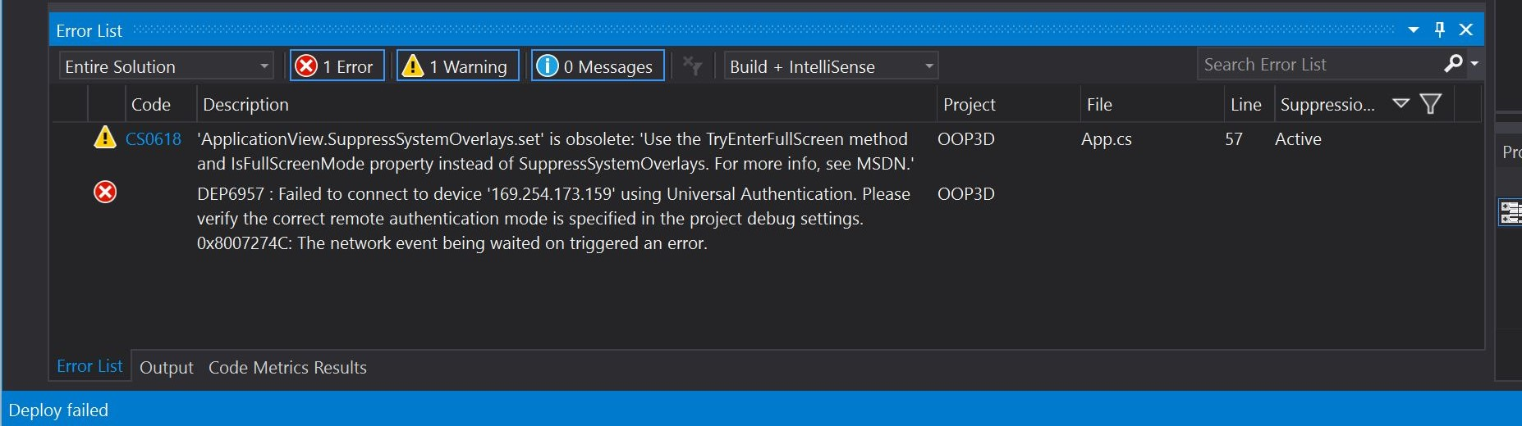

***Figure 1.*** Deployment Failure

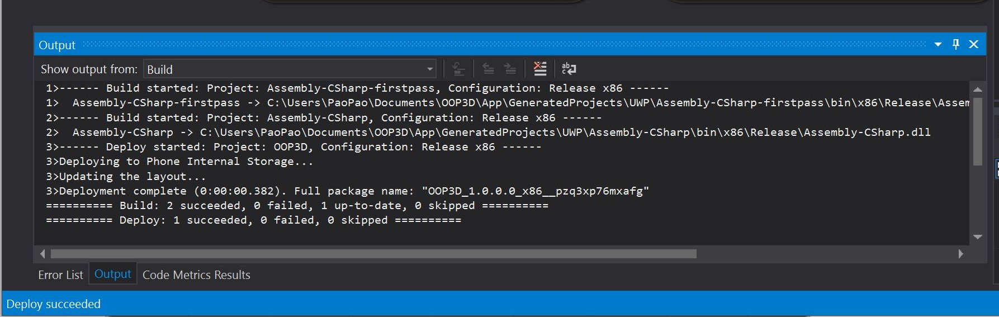

***Figure 2.*** Deployment Success

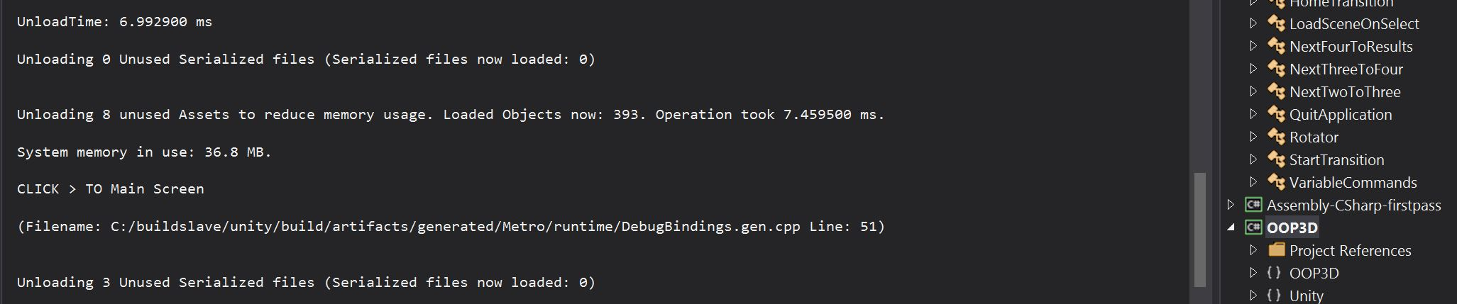

***Figure 3.*** Access Main Scene

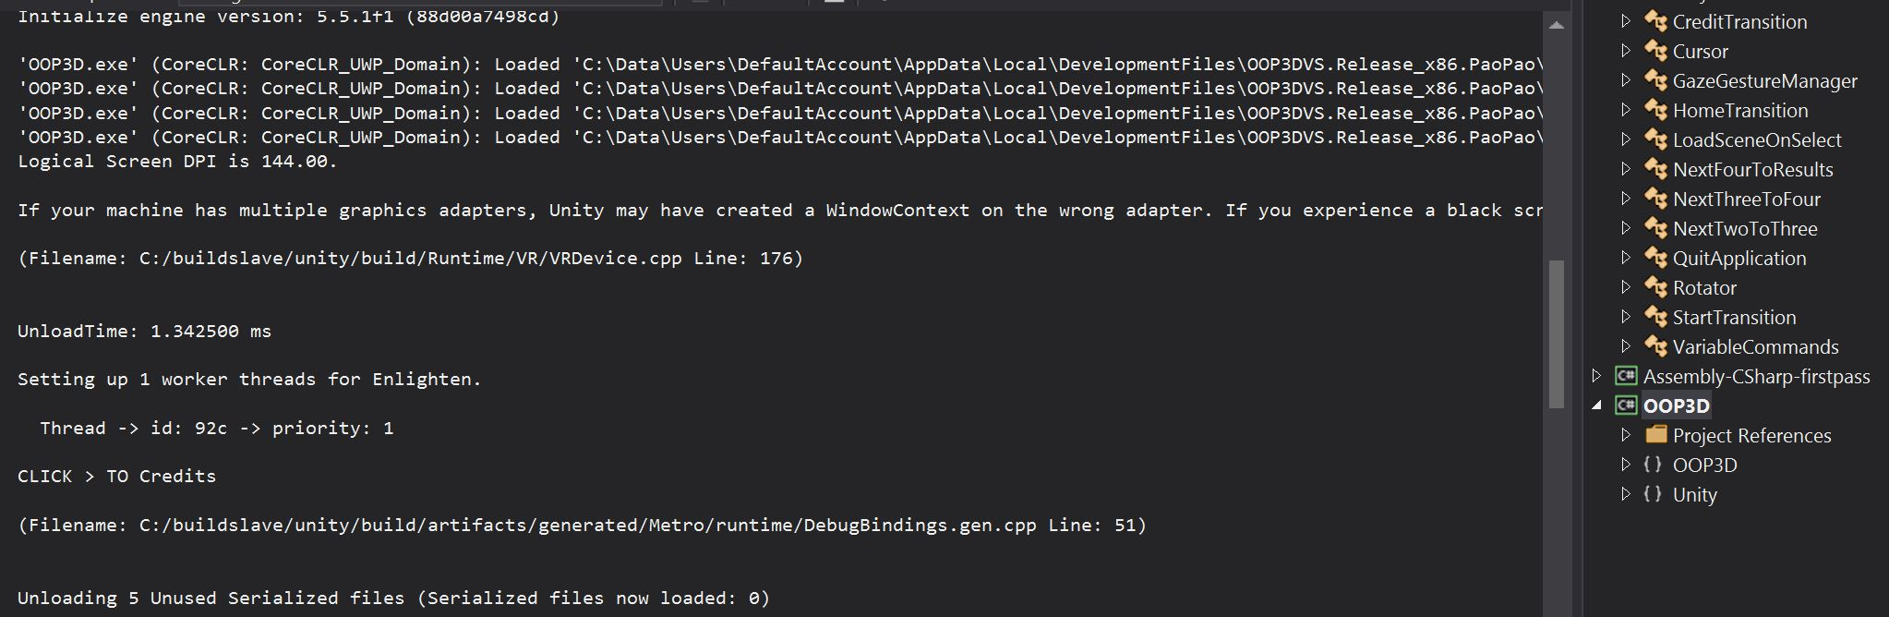

***Figure 4.*** Access Credits Scene

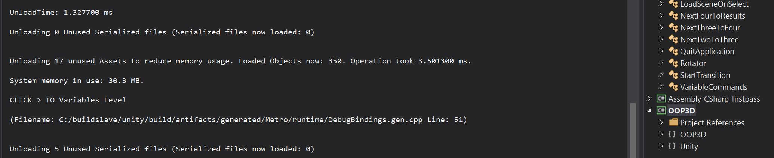

***Figure 5.*** Access Variables Scene

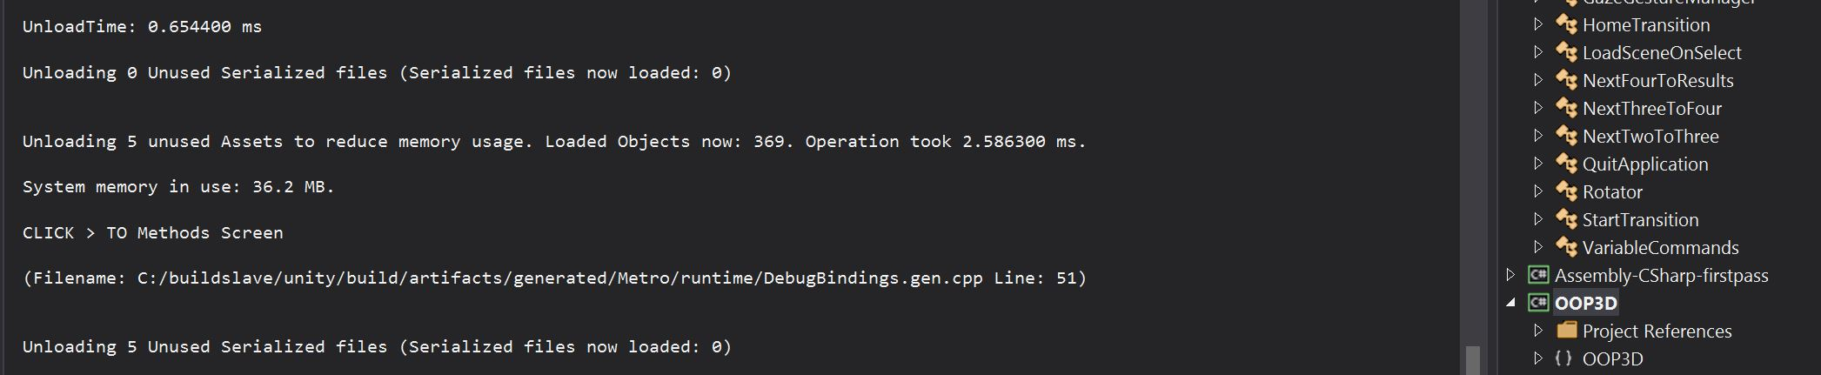

***Figure 6.*** Access Methods Scene

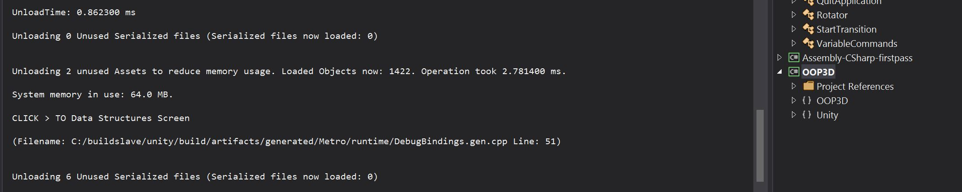

***Figure 7.*** Access Data Structures Scene

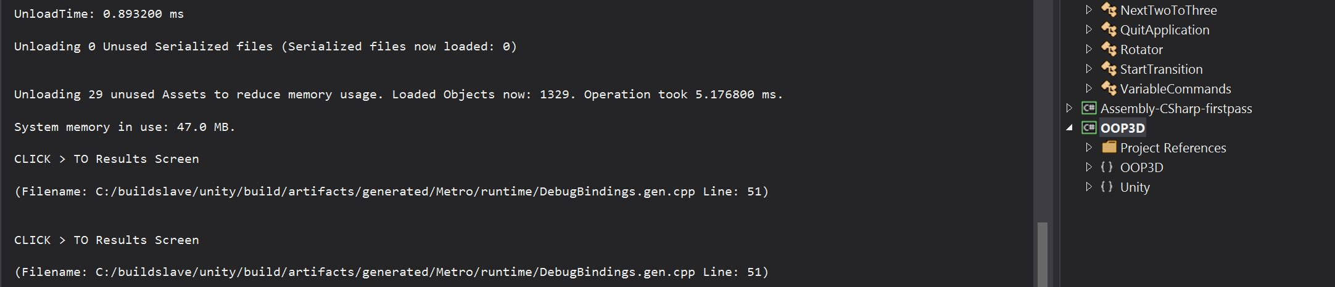

***Figure 8.*** Access Results Scene

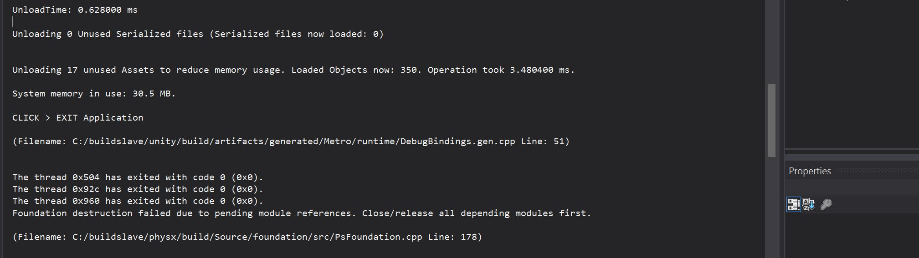

***Figure 9.*** Exit/Terminate the Application

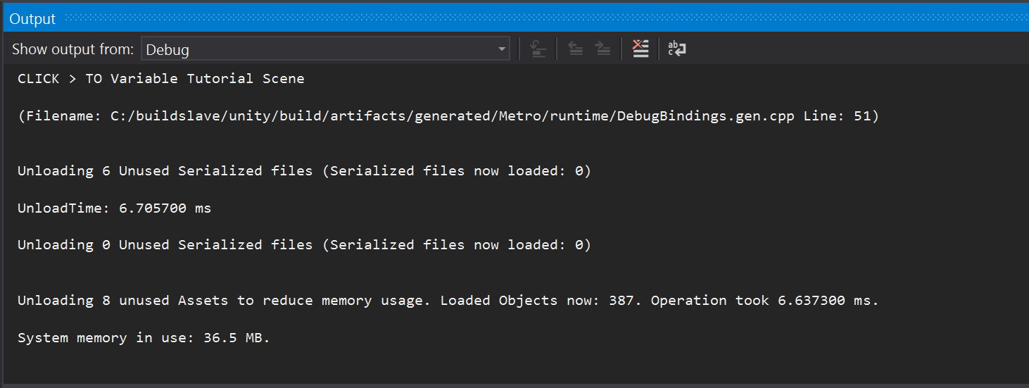***Figure 10.*** Variables Tutorial Scene Test

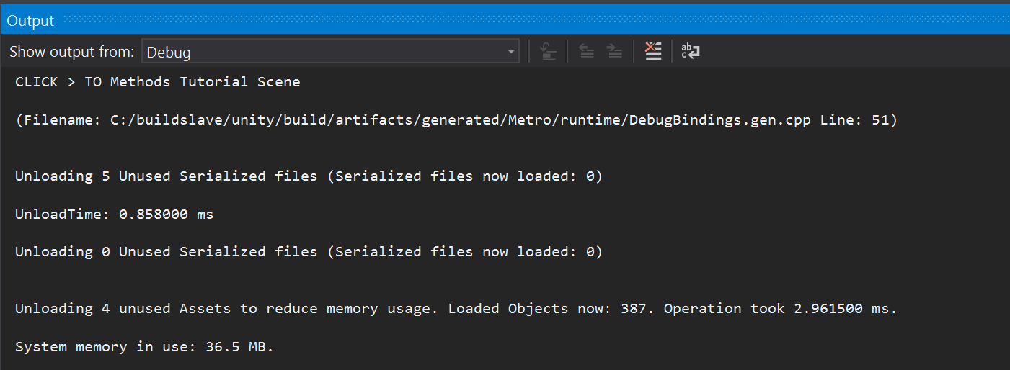***Figure 11.*** Methods Tutorial Scene Test

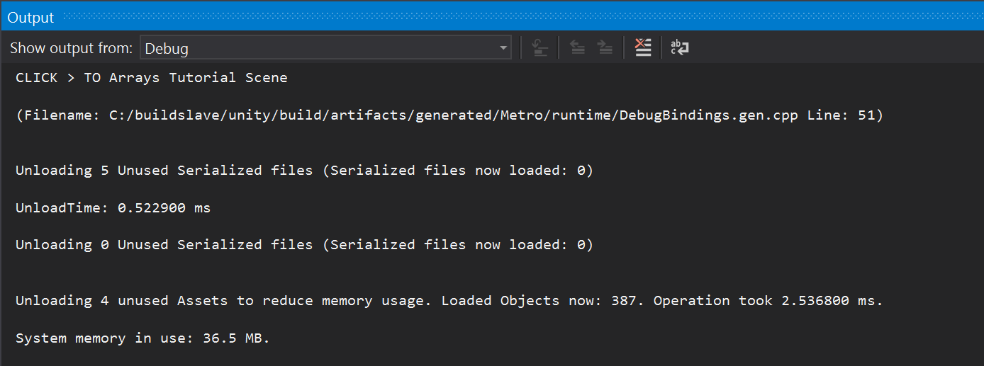***Figure 12.*** Arrays Tutorial Scene Test

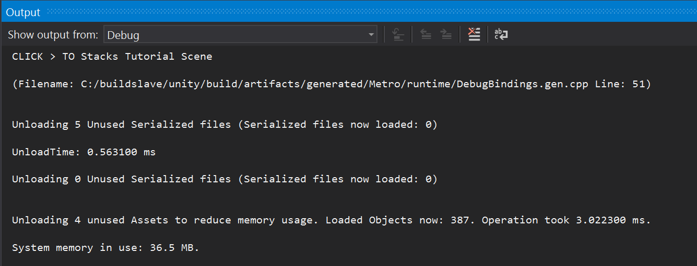

***Figure 13.*** Stacks Tutorial Scene Test

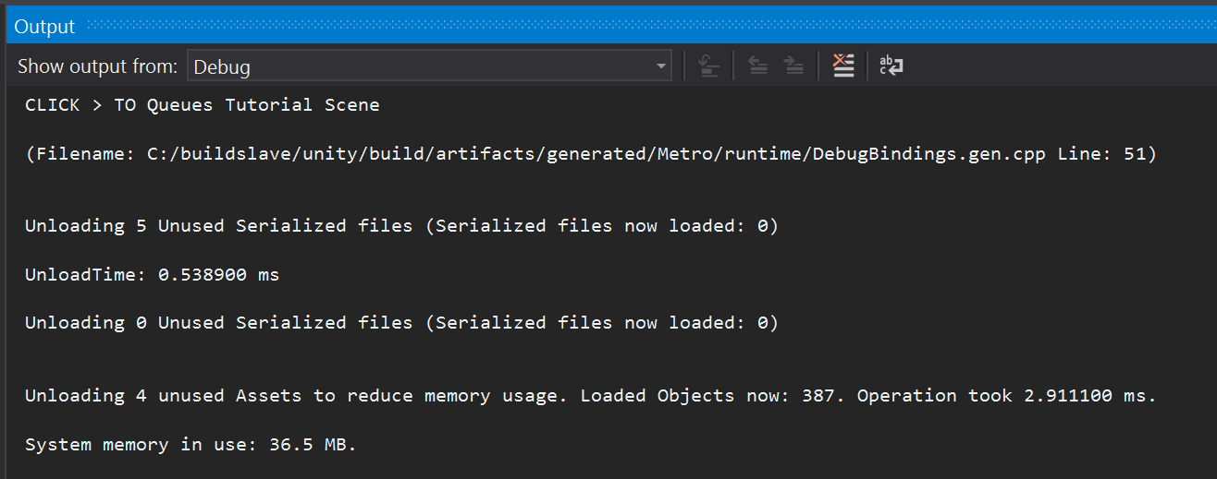

***Figure 14.*** Queues Tutorial Scene Test

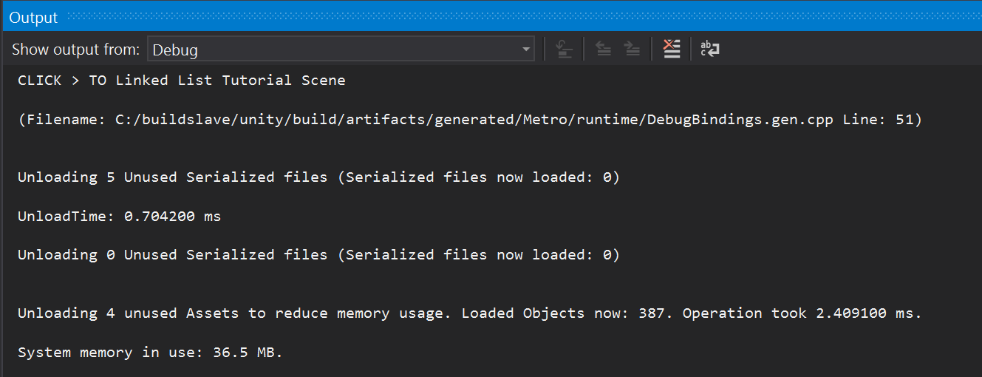

***Figure 15.*** Linked List Tutorial Scene Test

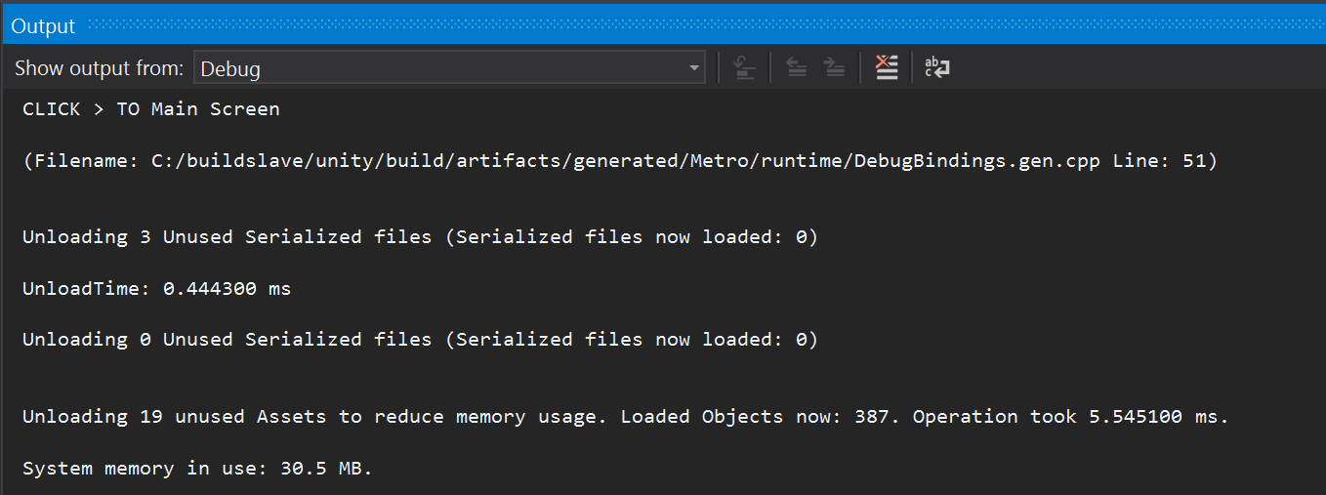

***Figure 16.*** Tutorial toMenu Scene Test

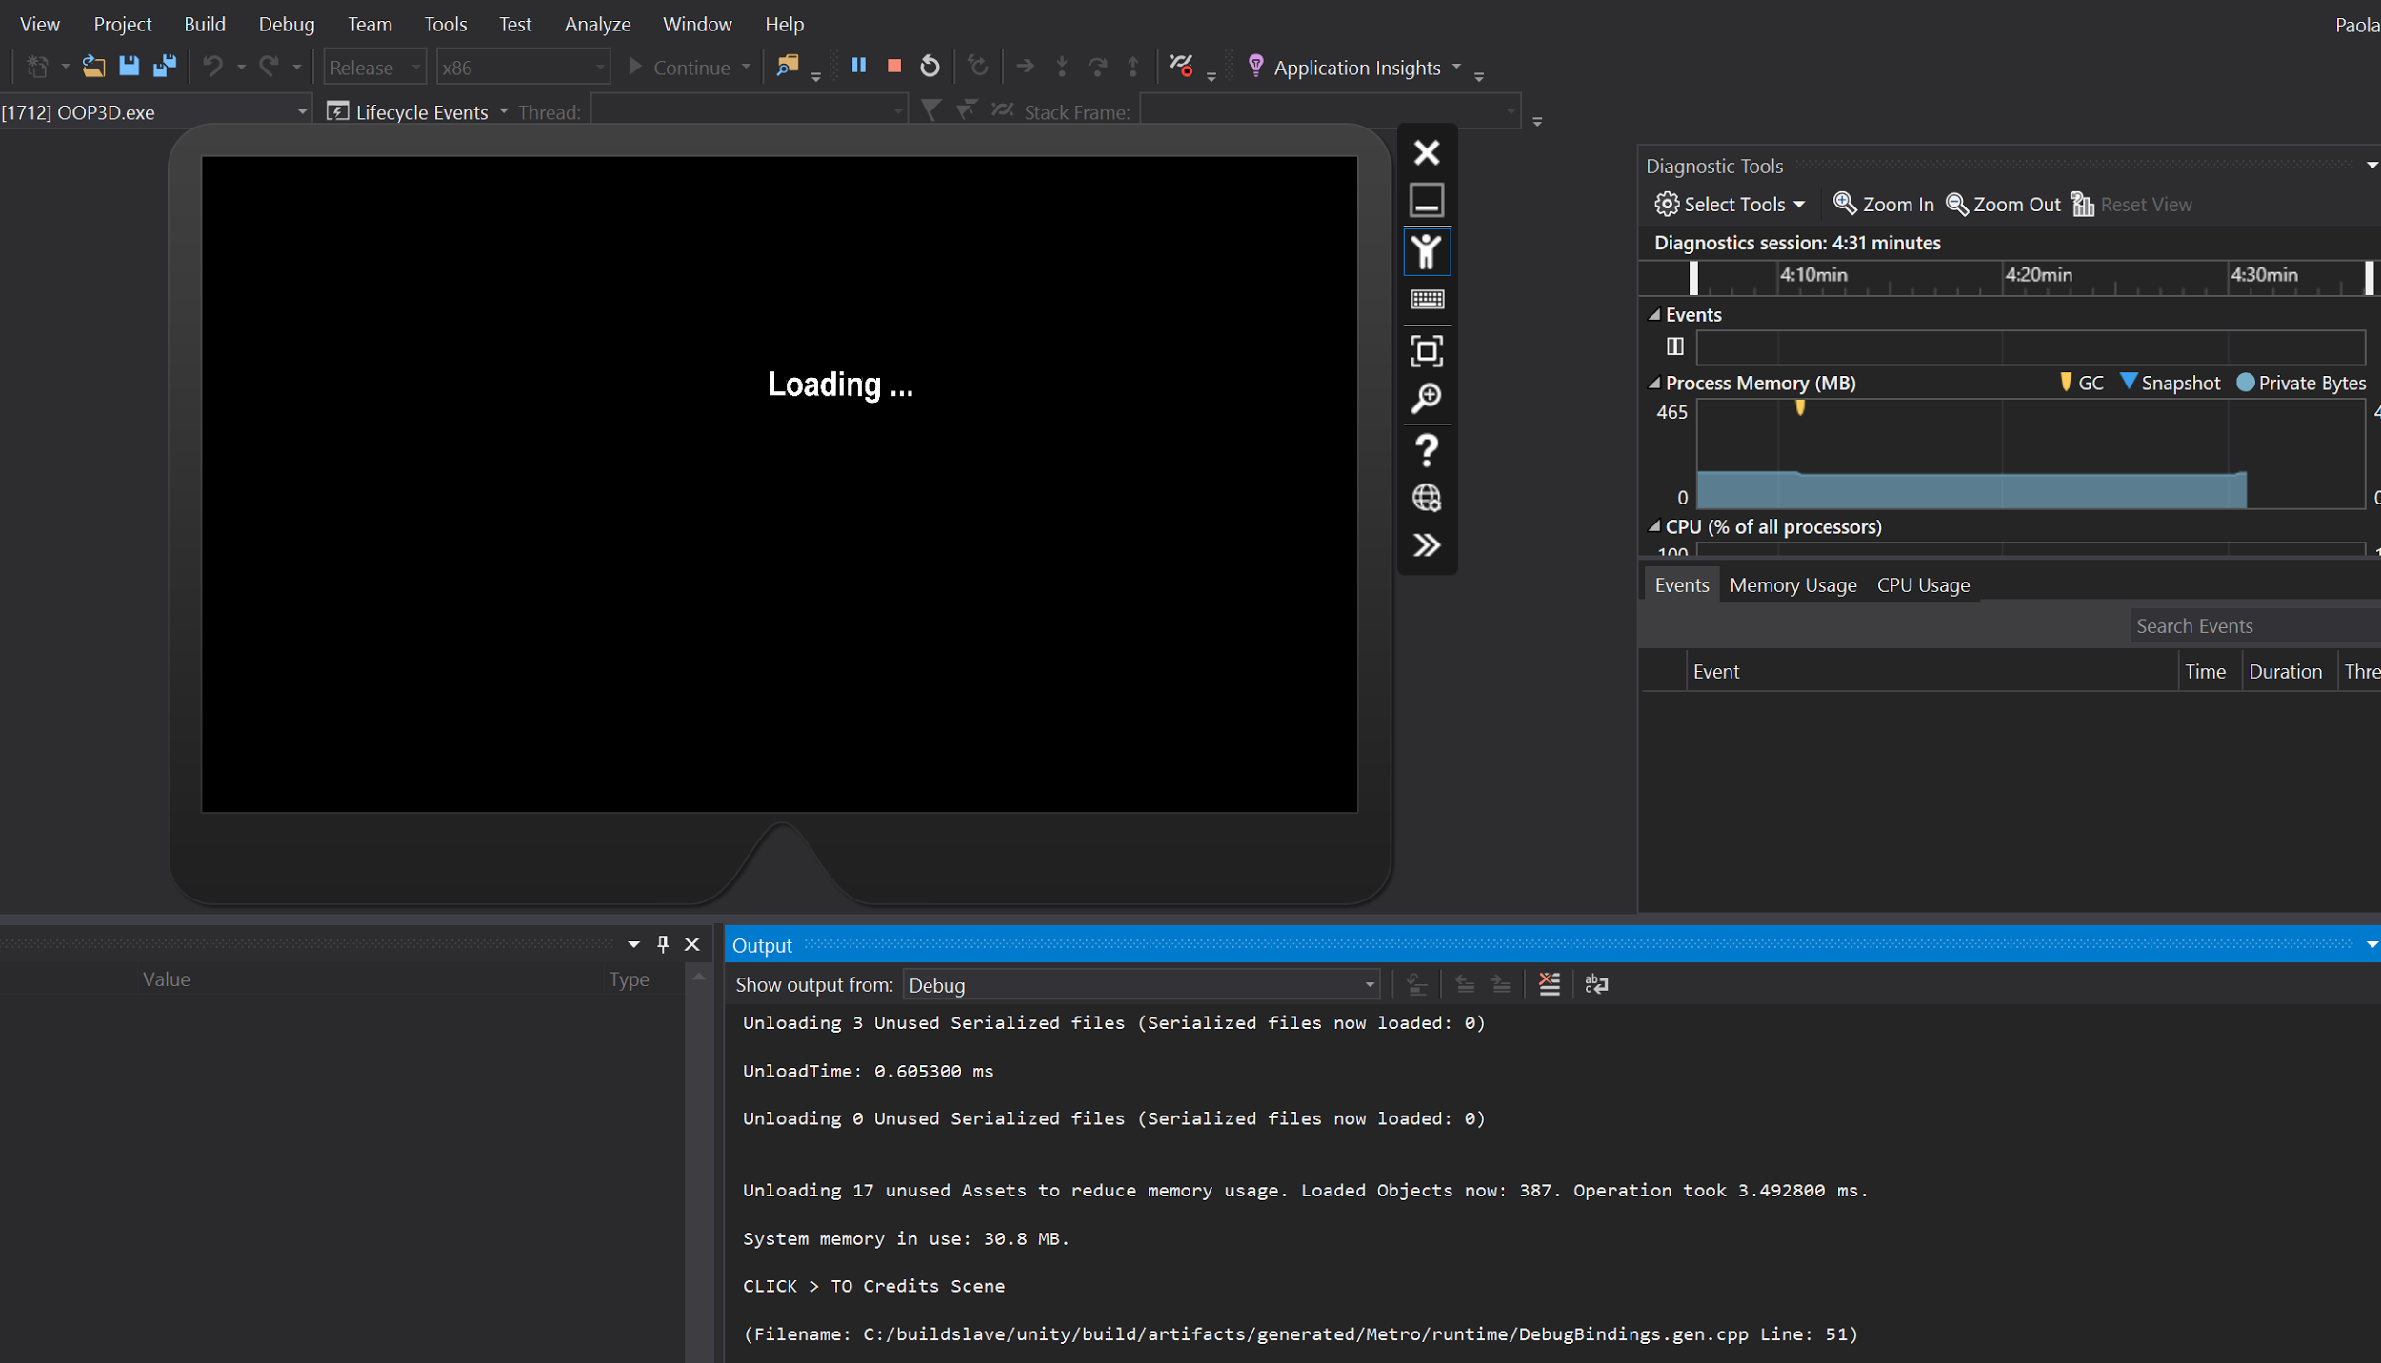

***Figure 17.*** User feedback 'Loading' scenes

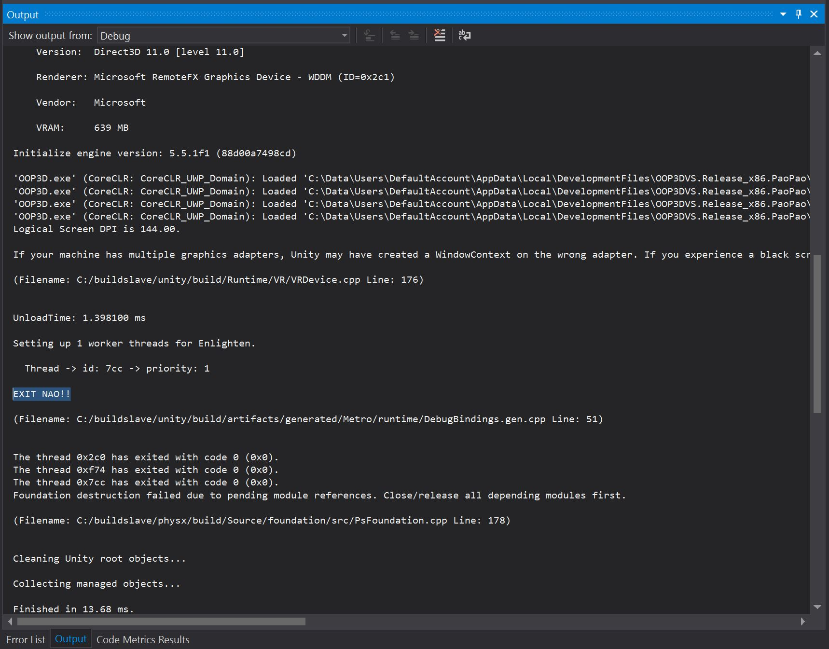

***Figure 18.*** Button Functionalities Test

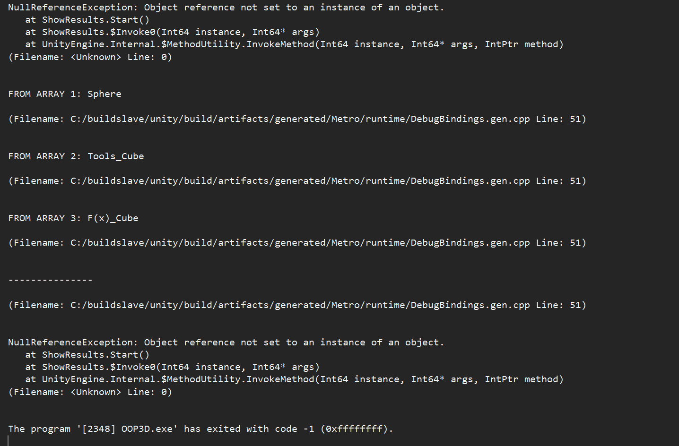

***Figure 19.*** Selections Results Test

# Glossary

|  |  |
| --- | --- |
| Agile | An umbrella term for several iterative and incremental software development methodologies. The most popular agile methodologies include Extreme Programming (XP), Scrum, Crystal, Dynamic Systems Development Method (DSDM), Lean Development, and Feature-Driven Development (FDD). |
| Augmented Reality (AR) | A live direct or indirect view of a physical, real-world environment whose elements are *augmented* (or supplemented) by computer-generated sensory input such as sound, video, graphics or [GPS](https://en.wikipedia.org/wiki/GPS) data. It is related to a more general concept called [mediated reality](https://en.wikipedia.org/wiki/Mediated_reality), in which a view of reality is modified (possibly even diminished rather than augmented) by a computer. Augmentation is conventionally in [real time](https://en.wikipedia.org/wiki/Real-time_computing) and in semantic context with environmental elements. |
| Computer Science (CS) | The study of the theory, experimentation, and engineering that form the basis for the design and use of [computers](https://en.wikipedia.org/wiki/Computer). It is the scientific and practical approach to [computation](https://en.wikipedia.org/wiki/Computation) and its applications and the systematic study of the feasibility, structure, expression, and mechanization of the methodical [procedures](https://en.wikipedia.org/wiki/Procedure_(computer_science)) (or [algorithms](https://en.wikipedia.org/wiki/Algorithm)) that underlie the acquisition, representation, processing, storage, communication of, and access to [information](https://en.wikipedia.org/wiki/Information). |
| Emulator | In [computing](https://en.wikipedia.org/wiki/Computing), an emulator is hardware or software that enables one computer system (called the *host*) to behave like another computer system (called the *guest*). An emulator typically enables the host system to run software or use peripheral devices designed for the guest system. Emulation refers to the ability of a [computer program](https://en.wikipedia.org/wiki/Computer_program) in an electronic device to emulate (or imitate) another program or device. |
| Gaze | Hololens uses the position and orientation of your user's head, not their eyes, to determine their gaze vector. Gaze Input in HoloLens indicate where the user is currently focusing on. |
| Gesture | Gestures allow users take action in mixed reality with their hands. For HoloLens, gesture input lets you interact with your holograms naturally. |
| Holograms | A three-dimensional image formed by the interference of light beams from a laser or other coherent light source (Hololens). |
| Hololens | Microsoft Hololens, known under development as Project Baraboo, is a pair of [mixed reality](https://en.wikipedia.org/wiki/Mixed_reality) [smart glasses](https://en.wikipedia.org/wiki/Smartglasses) developed and manufactured by [Microsoft](https://en.wikipedia.org/wiki/Microsoft). |
| Hyper-V | Codenamed Viridian and formerly known as Windows Server Virtualization, is a native [hypervisor](https://en.wikipedia.org/wiki/Hypervisor); it can create [virtual machines](https://en.wikipedia.org/wiki/Virtual_machine) on [x86-64](https://en.wikipedia.org/wiki/X86-64) systems running [Windows](https://en.wikipedia.org/wiki/Microsoft_Windows). Starting with [Windows 8](https://en.wikipedia.org/wiki/Windows_8), Hyper-V supersedes [Windows Virtual PC](https://en.wikipedia.org/wiki/Windows_Virtual_PC) as the [hardware virtualization](https://en.wikipedia.org/wiki/Hardware_virtualization) component of the client editions of [Windows NT](https://en.wikipedia.org/wiki/Windows_NT). A [server computer](https://en.wikipedia.org/wiki/Server_computer) running Hyper-V can be configured to expose individual virtual machines to one or more networks. |
| Mirroring | Also called screen casting allows the sharing of the Hololens device point of view via a remote computer or via direct physical connection to the device. |
| Object Oriented Programming (OOP) | A programming language model organized around objects rather than "actions" and data rather than logic. Historically, a program has been viewed as a logical procedure that takes input data, processes it, and produces output data. |
| Scrum | An Agile framework for completing complex projects. Scrum originally was formalized for software development projects, but it works well for any complex, innovative scope of work. |
| SDK | A software development kit (SDK or "devkit") is typically a set of software development tools that allows the creation of applications for a certain software package, software framework, hardware platform, computer system, video game console, operating system, or similar development platform. |
| Sprint | In the Scrum method of Agile software development, work is confined to a regular, repeatable work cycle, known as a sprint or iteration. Scrum sprints used to be 30 days long, but today we advise one-week or two-week sprints. ... Scrum is iterative and incremental. |
| User Story | A tool used in Agile software development to capture a description of a software feature from an end-user perspective. The user story describes the type of user, what they want and why. A user story helps to create a simplified description of a requirement. |

# Appendix

## Appendix A - UML Diagrams

**Class Diagram**

## 

## 

|  |
| --- |
| **Class Diagram** |

|  |  |
| --- | --- |
| X | Includes associations |
| X | Includes attributes |
| X | Includes classes |
| X | Includes objects |
| X | Includes relationships |

|  |
| --- |
| **Class Name** |

|  |  |
| --- | --- |
| X | Class Name begins with a noun |
| X | First letter is capitalized |

|  |
| --- |
| **Class body** |

|  |  |
| --- | --- |
| X | Class name located in the top section and are centered |
| X | Attributes located in the middle section |
| X | Methods located in the bottom section |

|  |
| --- |
| **Attributes and Methods** |

|  |  |
| --- | --- |
| X | Attributes begin with a first lower case letter |
| X | Methods begin with a first lower case letter |
| X | No spaces between the words for attributes and methods |

|  |
| --- |
| **Compliance of the documentation guidelines** |

|  |  |
| --- | --- |
| X | Is UML syntax correct? |
| X | Does the class have attributes and methods? |
| X | Have the class relationships with other classes? |
| X | Are attributes and methods formally described? |

**Finite State Machine**

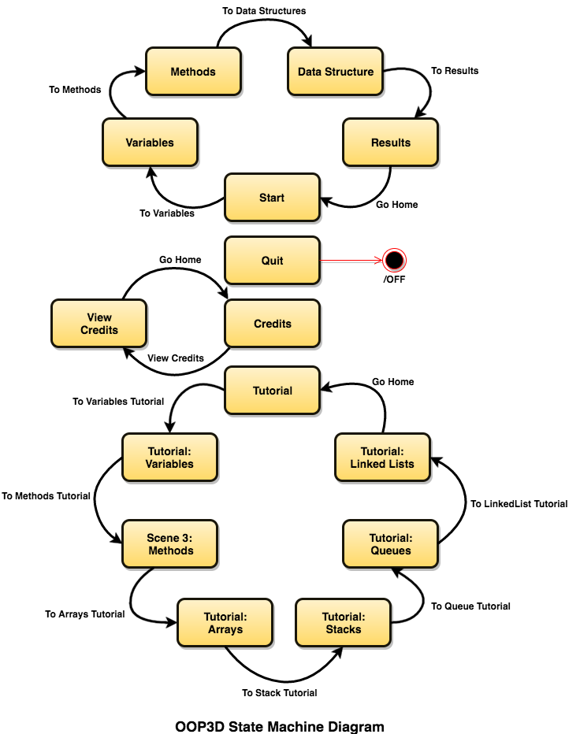

## Appendix B - Interaction Viewpoint

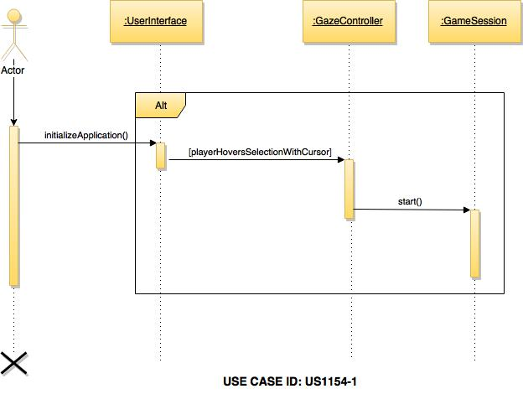

|  |
| --- |
| **Sequence Diagram** |

|  |  |
| --- | --- |
| X | Includes actors |
| X | Includes lifelines |
| X | Includes activations |
| X | Includes entity objects |
| X | Includes control objects |
| X | Includes method call in the receiving class for each received message |
| X | Includes method call in the sending class for each sent message |
| X | Includes messages |

|  |
| --- |
| **Standards** |

|  |  |
| --- | --- |
| X | Actors are a stick figure with full name |
| X | Message is a solid line with a filled arrow ahead |
| X | Return message are a dashed line with an open arrowhead |
| X | One outgoing action arrow per action box |

|  |
| --- |
| **Compliance of the document guidelines** |

|  |  |
| --- | --- |
| X | Is UML syntax correct? |
| X | Is there an Actor? |
| X | When there is more than one object for a class (also in other sequence diagrams) are those objects referenced with proper names? |
| X | Does the diagram cover the user case scenario? |

|  |
| --- |
| **Internal consistence of the model** |

|  |  |
| --- | --- |
| X | Is there a scenario for the sequence diagram? |
| X | Is there a documentation to which scenario belongs a sequence diagram? |
| X | Is the scenario information correctly described? |
| X | When an object of a class receives notifications, are those notifications mapped as events? |
| X | When an object of a class receives notifications, are those notifications mapped as methods defined in the class? |
| X | When an object of a class receives notifications, are those notifications mapped as actions in the State Diagrams? |
| X | Are all objects the same as shown on the class diagram? |
| X | Are there activation lifelines (rectangles) to show created and deleted objects? |
| X | Can each message be sent? |
| X | Is each class in the class diagram? |
| X | Is there a method call in the receiving class for each received message? |

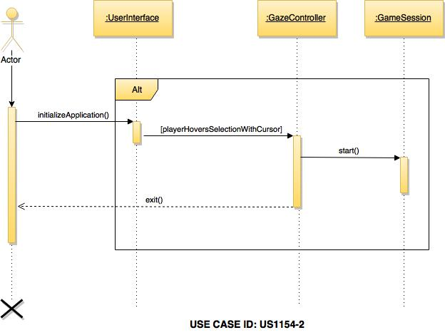

|  |
| --- |
| **Sequence Diagram** |

|  |  |
| --- | --- |
| X | Includes actors |
| X | Includes lifelines |
| X | Includes activations |
| X | Includes entity objects |
| X | Includes control objects |
| X | Includes method call in the receiving class for each received message |
| X | Includes method call in the sending class for each sent message |
| X | Includes messages |

|  |
| --- |
| **Standards** |

|  |  |
| --- | --- |
| X | Actors are a stick figure with full name |
| X | Message is a solid line with a filled arrow ahead |
| X | Return message are a dashed line with an open arrowhead |
| X | One outgoing action arrow per action box |

|  |
| --- |
| **Compliance of the document guidelines** |

|  |  |
| --- | --- |
| X | Is UML syntax correct? |
| X | Is there an Actor? |
| X | When there is more than one object for a class (also in other sequence diagrams) are those objects referenced with proper names? |
| X | Does the diagram cover the user case scenario? |

|  |
| --- |
| **Internal consistence of the model** |

|  |  |
| --- | --- |
| X | Is there a scenario for the sequence diagram? |
| X | Is there a documentation to which scenario belongs a sequence diagram? |
| X | Is the scenario information correctly described? |
| X | When an object of a class receives notifications, are those notifications mapped as events? |
| X | When an object of a class receives notifications, are those notifications mapped as methods defined in the class? |
| X | When an object of a class receives notifications, are those notifications mapped as actions in the State Diagrams? |
| X | Are all objects the same as shown on the class diagram? |
| X | Are there activation lifelines (rectangles) to show created and deleted objects? |
| X | Can each message be sent? |
| X | Is each class in the class diagram? |
| X | Is there a method call in the receiving class for each received message? |

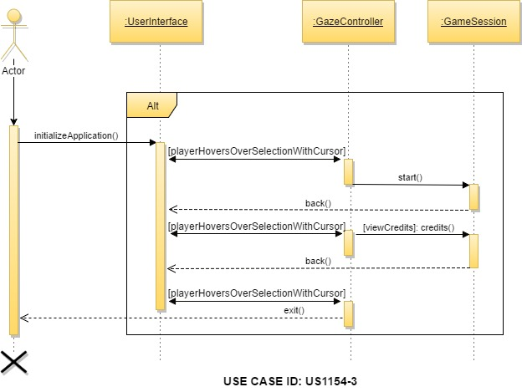

|  |
| --- |
| **Sequence Diagram** |

|  |  |
| --- | --- |
| X | Includes actors |
| X | Includes lifelines |
| X | Includes activations |
| X | Includes entity objects |
| X | Includes control objects |
| X | Includes method call in the receiving class for each received message |
| X | Includes method call in the sending class for each sent message |
| X | Includes messages |

|  |
| --- |
| **Standards** |

|  |  |
| --- | --- |
| X | Actors are a stick figure with full name |
| X | Message is a solid line with a filled arrow ahead |
| X | Return message are a dashed line with an open arrowhead |
| X | One outgoing action arrow per action box |

|  |
| --- |
| **Compliance of the document guidelines** |

|  |  |
| --- | --- |
| X | Is UML syntax correct? |
| X | Is there an Actor? |
| X | When there is more than one object for a class (also in other sequence diagrams) are those objects referenced with proper names? |
| X | Does the diagram cover the user case scenario? |

|  |
| --- |
| **Internal consistence of the model** |

|  |  |
| --- | --- |
| X | Is there a scenario for the sequence diagram? |
| X | Is there a documentation to which scenario belongs a sequence diagram? |
| X | Is the scenario information correctly described? |
| X | When an object of a class receives notifications, are those notifications mapped as events? |
| X | When an object of a class receives notifications, are those notifications mapped as methods defined in the class? |
| X | When an object of a class receives notifications, are those notifications mapped as actions in the State Diagrams? |
| X | Are all objects the same as shown on the class diagram? |
| X | Are there activation lifelines (rectangles) to show created and deleted objects? |
| X | Can each message be sent? |
| X | Is each class in the class diagram? |
| X | Is there a method call in the receiving class for each received message? |

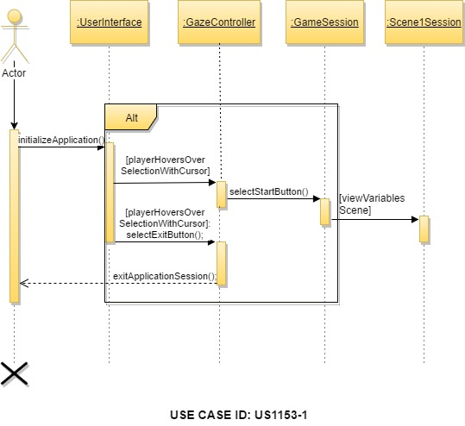

|  |
| --- |
| **Sequence Diagram** |

|  |  |
| --- | --- |
| X | Includes actors |
| X | Includes lifelines |
| X | Includes activations |
| X | Includes entity objects |
| X | Includes control objects |
| X | Includes method call in the receiving class for each received message |
| X | Includes method call in the sending class for each sent message |
| X | Includes messages |

|  |
| --- |
| **Standards** |

|  |  |
| --- | --- |
| X | Actors are a stick figure with full name |
| X | Message is a solid line with a filled arrow ahead |
| X | Return message are a dashed line with an open arrowhead |
| X | One outgoing action arrow per action box |

|  |
| --- |
| **Compliance of the document guidelines** |

|  |  |
| --- | --- |
| X | Is UML syntax correct? |
| X | Is there an Actor? |
| X | When there is more than one object for a class (also in other sequence diagrams) are those objects referenced with proper names? |
| X | Does the diagram cover the user case scenario? |

|  |
| --- |
| **Internal consistence of the model** |

|  |  |
| --- | --- |
| X | Is there a scenario for the sequence diagram? |
| X | Is there a documentation to which scenario belongs a sequence diagram? |
| X | Is the scenario information correctly described? |
| X | When an object of a class receives notifications, are those notifications mapped as events? |
| X | When an object of a class receives notifications, are those notifications mapped as methods defined in the class? |
| X | When an object of a class receives notifications, are those notifications mapped as actions in the State Diagrams? |
| X | Are all objects the same as shown on the class diagram? |
| X | Are there activation lifelines (rectangles) to show created and deleted objects? |
| X | Can each message be sent? |
| X | Is each class in the class diagram? |
| X | Is there a method call in the receiving class for each received message? |

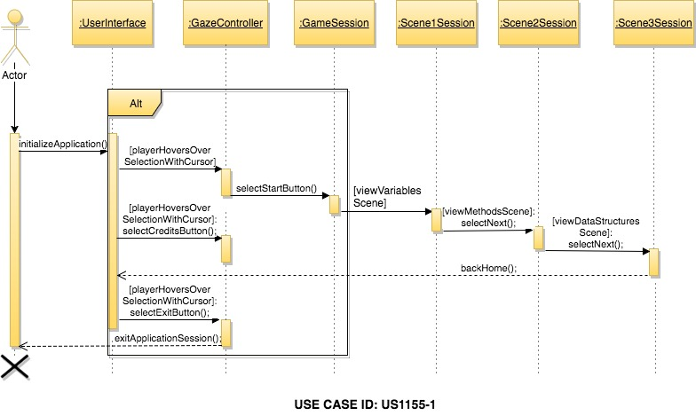

|  |
| --- |
| **Sequence Diagram** |

|  |  |
| --- | --- |
| X | Includes actors |
| X | Includes lifelines |
| X | Includes activations |
| X | Includes entity objects |
| X | Includes control objects |
| X | Includes method call in the receiving class for each received message |
| X | Includes method call in the sending class for each sent message |
| X | Includes messages |

|  |
| --- |
| **Standards** |

|  |  |
| --- | --- |
| X | Actors are a stick figure with full name |
| X | Message is a solid line with a filled arrow ahead |
| X | Return message are a dashed line with an open arrowhead |
| X | One outgoing action arrow per action box |

|  |
| --- |
| **Compliance of the document guidelines** |

|  |  |
| --- | --- |
| X | Is UML syntax correct? |
| X | Is there an Actor? |
| X | When there is more than one object for a class (also in other sequence diagrams) are those objects referenced with proper names? |
| X | Does the diagram cover the user case scenario? |

|  |
| --- |
| **Internal consistence of the model** |

|  |  |
| --- | --- |
| X | Is there a scenario for the sequence diagram? |
| X | Is there a documentation to which scenario belongs a sequence diagram? |
| X | Is the scenario information correctly described? |
| X | When an object of a class receives notifications, are those notifications mapped as events? |
| X | When an object of a class receives notifications, are those notifications mapped as methods defined in the class? |
| X | When an object of a class receives notifications, are those notifications mapped as actions in the State Diagrams? |
| X | Are all objects the same as shown on the class diagram? |
| X | Are there activation lifelines (rectangles) to show created and deleted objects? |
| X | Can each message be sent? |
| X | Is each class in the class diagram? |
| X | Is there a method call in the receiving class for each received message? |

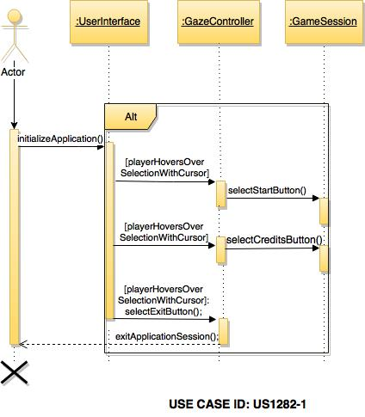

|  |
| --- |
| **Sequence Diagram** |

|  |  |
| --- | --- |
| X | Includes actors |
| X | Includes lifelines |
| X | Includes activations |
| X | Includes entity objects |
| X | Includes control objects |
| X | Includes method call in the receiving class for each received message |
| X | Includes method call in the sending class for each sent message |
| X | Includes messages |

|  |
| --- |
| **Standards** |

|  |  |
| --- | --- |
| X | Actors are a stick figure with full name |
| X | Message is a solid line with a filled arrow ahead |
| X | Return message are a dashed line with an open arrowhead |
| X | One outgoing action arrow per action box |

|  |
| --- |
| **Compliance of the document guidelines** |

|  |  |
| --- | --- |
| X | Is UML syntax correct? |
| X | Is there an Actor? |
| X | When there is more than one object for a class (also in other sequence diagrams) are those objects referenced with proper names? |
| X | Does the diagram cover the user case scenario? |

|  |
| --- |
| **Internal consistence of the model** |

|  |  |
| --- | --- |
| X | Is there a scenario for the sequence diagram? |
| X | Is there a documentation to which scenario belongs a sequence diagram? |
| X | Is the scenario information correctly described? |
| X | When an object of a class receives notifications, are those notifications mapped as events? |
| X | When an object of a class receives notifications, are those notifications mapped as methods defined in the class? |
| X | When an object of a class receives notifications, are those notifications mapped as actions in the State Diagrams? |
| X | Are all objects the same as shown on the class diagram? |
| X | Are there activation lifelines (rectangles) to show created and deleted objects? |
| X | Can each message be sent? |
| X | Is each class in the class diagram? |
| X | Is there a method call in the receiving class for each received message? |

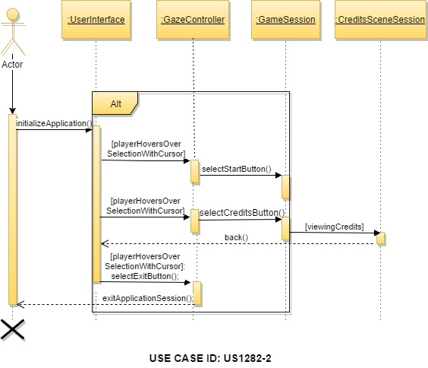

|  |
| --- |
| **Sequence Diagram** |

|  |  |
| --- | --- |
| X | Includes actors |
| X | Includes lifelines |
| X | Includes activations |
| X | Includes entity objects |
| X | Includes control objects |
| X | Includes method call in the receiving class for each received message |
| X | Includes method call in the sending class for each sent message |
| X | Includes messages |

|  |
| --- |
| **Standards** |

|  |  |
| --- | --- |
| X | Actors are a stick figure with full name |
| X | Message is a solid line with a filled arrow ahead |
| X | Return message are a dashed line with an open arrowhead |
| X | One outgoing action arrow per action box |

|  |
| --- |
| **Compliance of the document guidelines** |

|  |  |
| --- | --- |
| X | Is UML syntax correct? |
| X | Is there an Actor? |
| X | When there is more than one object for a class (also in other sequence diagrams) are those objects referenced with proper names? |
| X | Does the diagram cover the user case scenario? |

|  |
| --- |
| **Internal consistence of the model** |

|  |  |
| --- | --- |
| X | Is there a scenario for the sequence diagram? |
| X | Is there a documentation to which scenario belongs a sequence diagram? |
| X | Is the scenario information correctly described? |
| X | When an object of a class receives notifications, are those notifications mapped as events? |
| X | When an object of a class receives notifications, are those notifications mapped as methods defined in the class? |
| X | When an object of a class receives notifications, are those notifications mapped as actions in the State Diagrams? |
| X | Are all objects the same as shown on the class diagram? |
| X | Are there activation lifelines (rectangles) to show created and deleted objects? |
| X | Can each message be sent? |
| X | Is each class in the class diagram? |
| X | Is there a method call in the receiving class for each received message? |

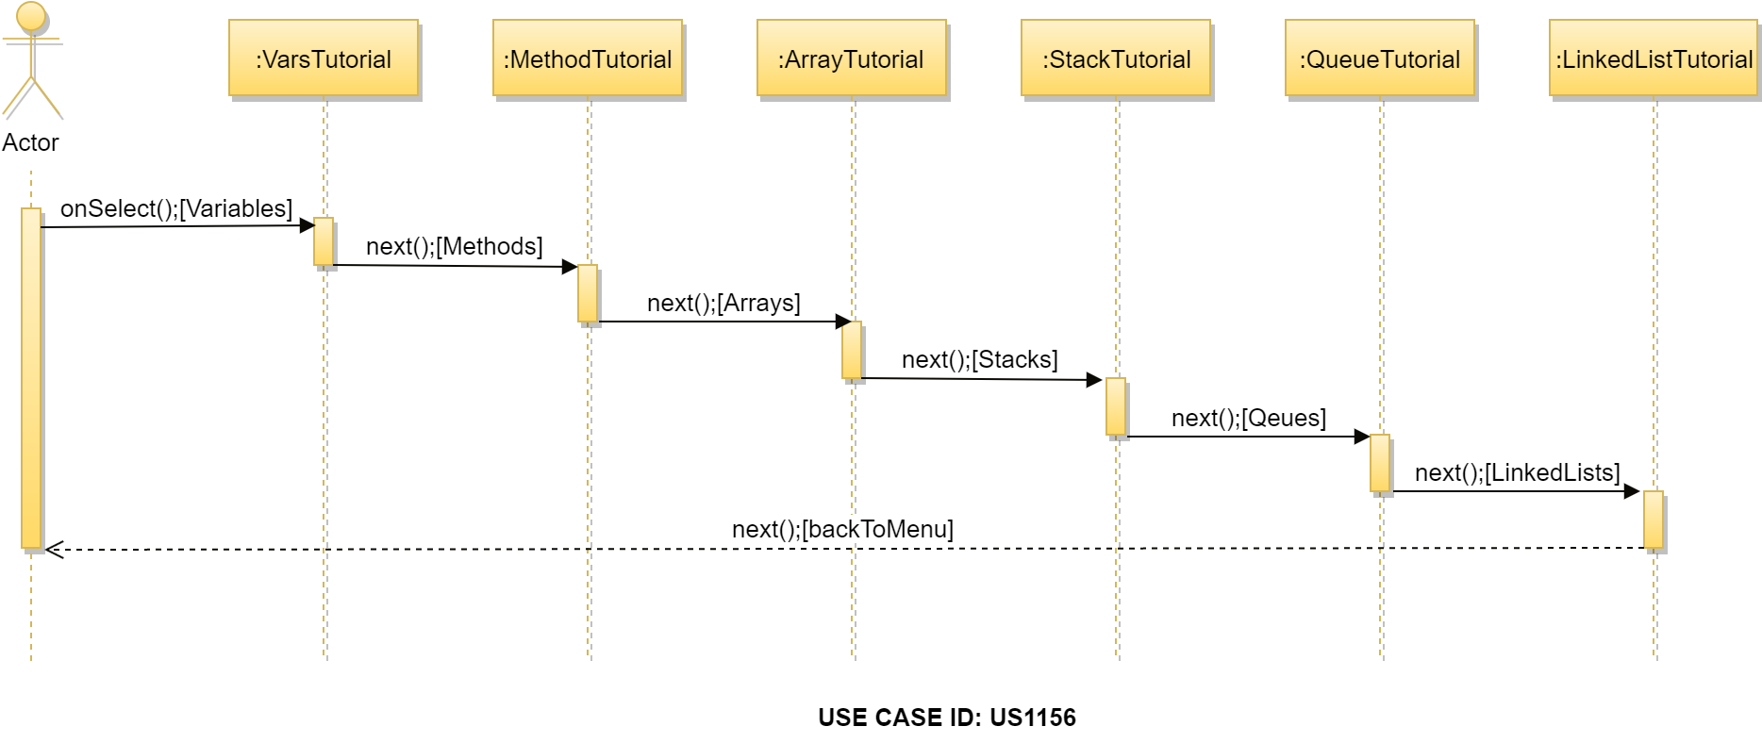

|  |
| --- |
| **Sequence Diagram** |

|  |  |
| --- | --- |
| X | Includes actors |
| X | Includes lifelines |
| X | Includes activations |
| X | Includes entity objects |
| X | Includes control objects |
| X | Includes method call in the receiving class for each received message |
| X | Includes method call in the sending class for each sent message |
| X | Includes messages |

|  |
| --- |
| **Standards** |

|  |  |
| --- | --- |
| X | Actors are a stick figure with full name |
| X | Message is a solid line with a filled arrow ahead |
| X | Return message are a dashed line with an open arrowhead |
| X | One outgoing action arrow per action box |

|  |
| --- |
| **Compliance of the document guidelines** |

|  |  |
| --- | --- |
| X | Is UML syntax correct? |
| X | Is there an Actor? |
| X | When there is more than one object for a class (also in other sequence diagrams) are those objects referenced with proper names? |
| X | Does the diagram cover the user case scenario? |

|  |
| --- |
| **Internal consistence of the model** |

|  |  |
| --- | --- |
| X | Is there a scenario for the sequence diagram? |
| X | Is there a documentation to which scenario belongs a sequence diagram? |
| X | Is the scenario information correctly described? |
| X | When an object of a class receives notifications, are those notifications mapped as events? |
| X | When an object of a class receives notifications, are those notifications mapped as methods defined in the class? |
| X | When an object of a class receives notifications, are those notifications mapped as actions in the State Diagrams? |
| X | Are all objects the same as shown on the class diagram? |
| X | Are there activation lifelines (rectangles) to show created and deleted objects? |
| X | Can each message be sent? |
| X | Is each class in the class diagram? |
| X | Is there a method call in the receiving class for each received message? |

## 

## 

## Appendix C - User Interface Design

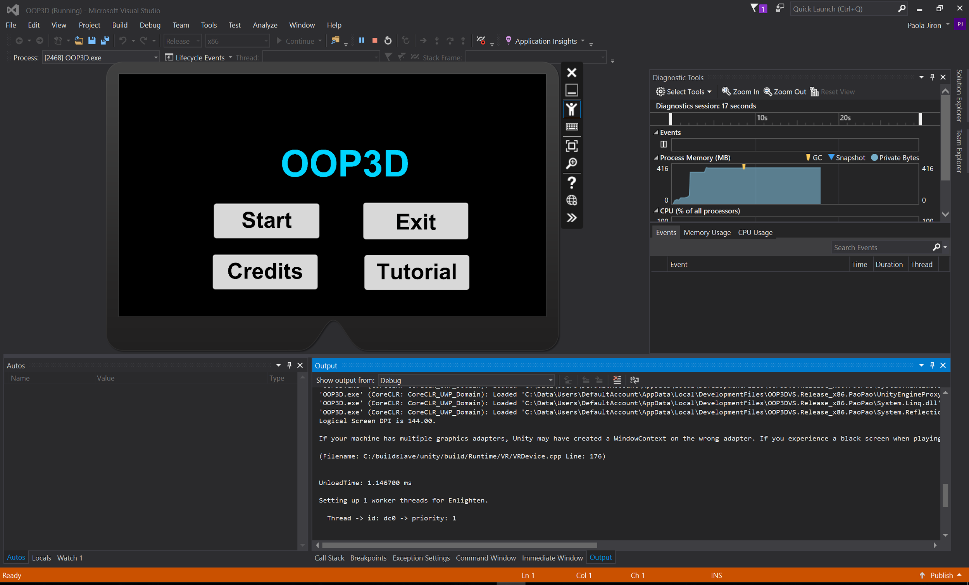

***Figure 1.*** Menu including Tutorials Button

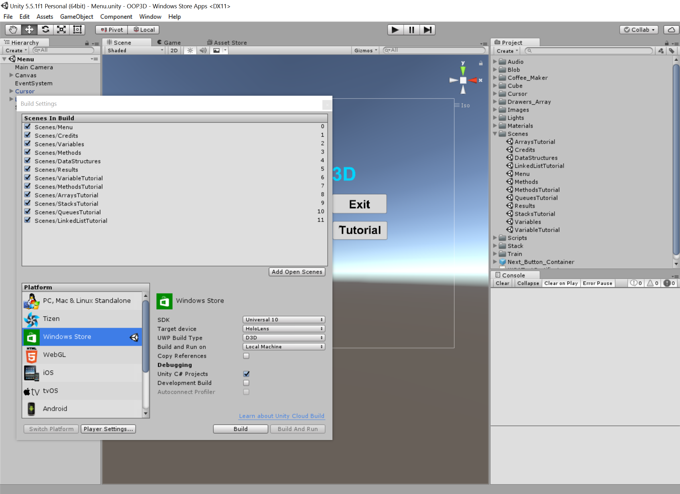

***Figure 2.*** All scenes including Tutorials in Unity

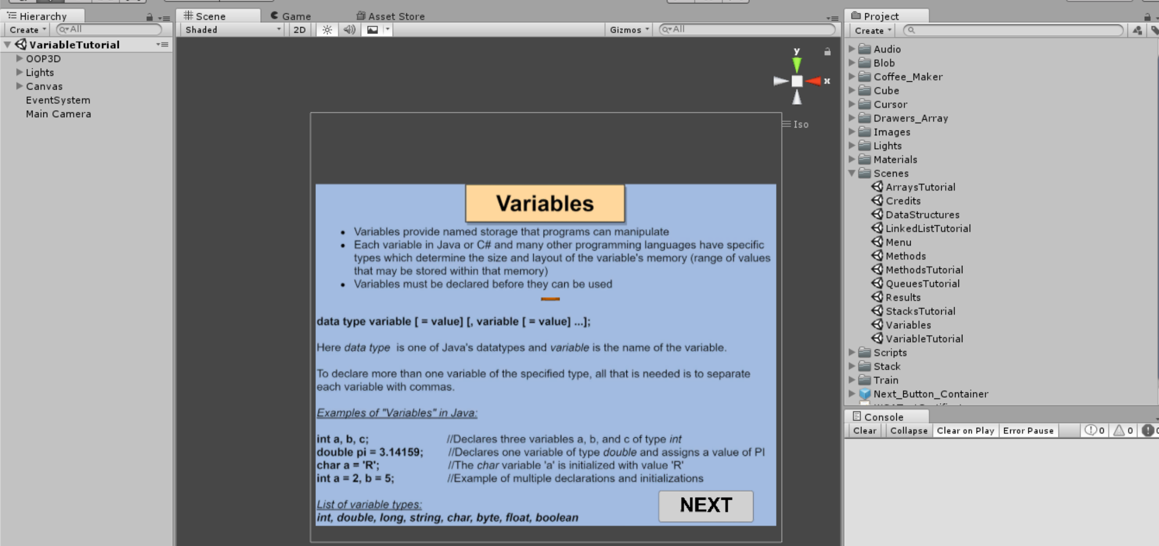

***Figure 3.*** Variables Scene Tutorials Unity

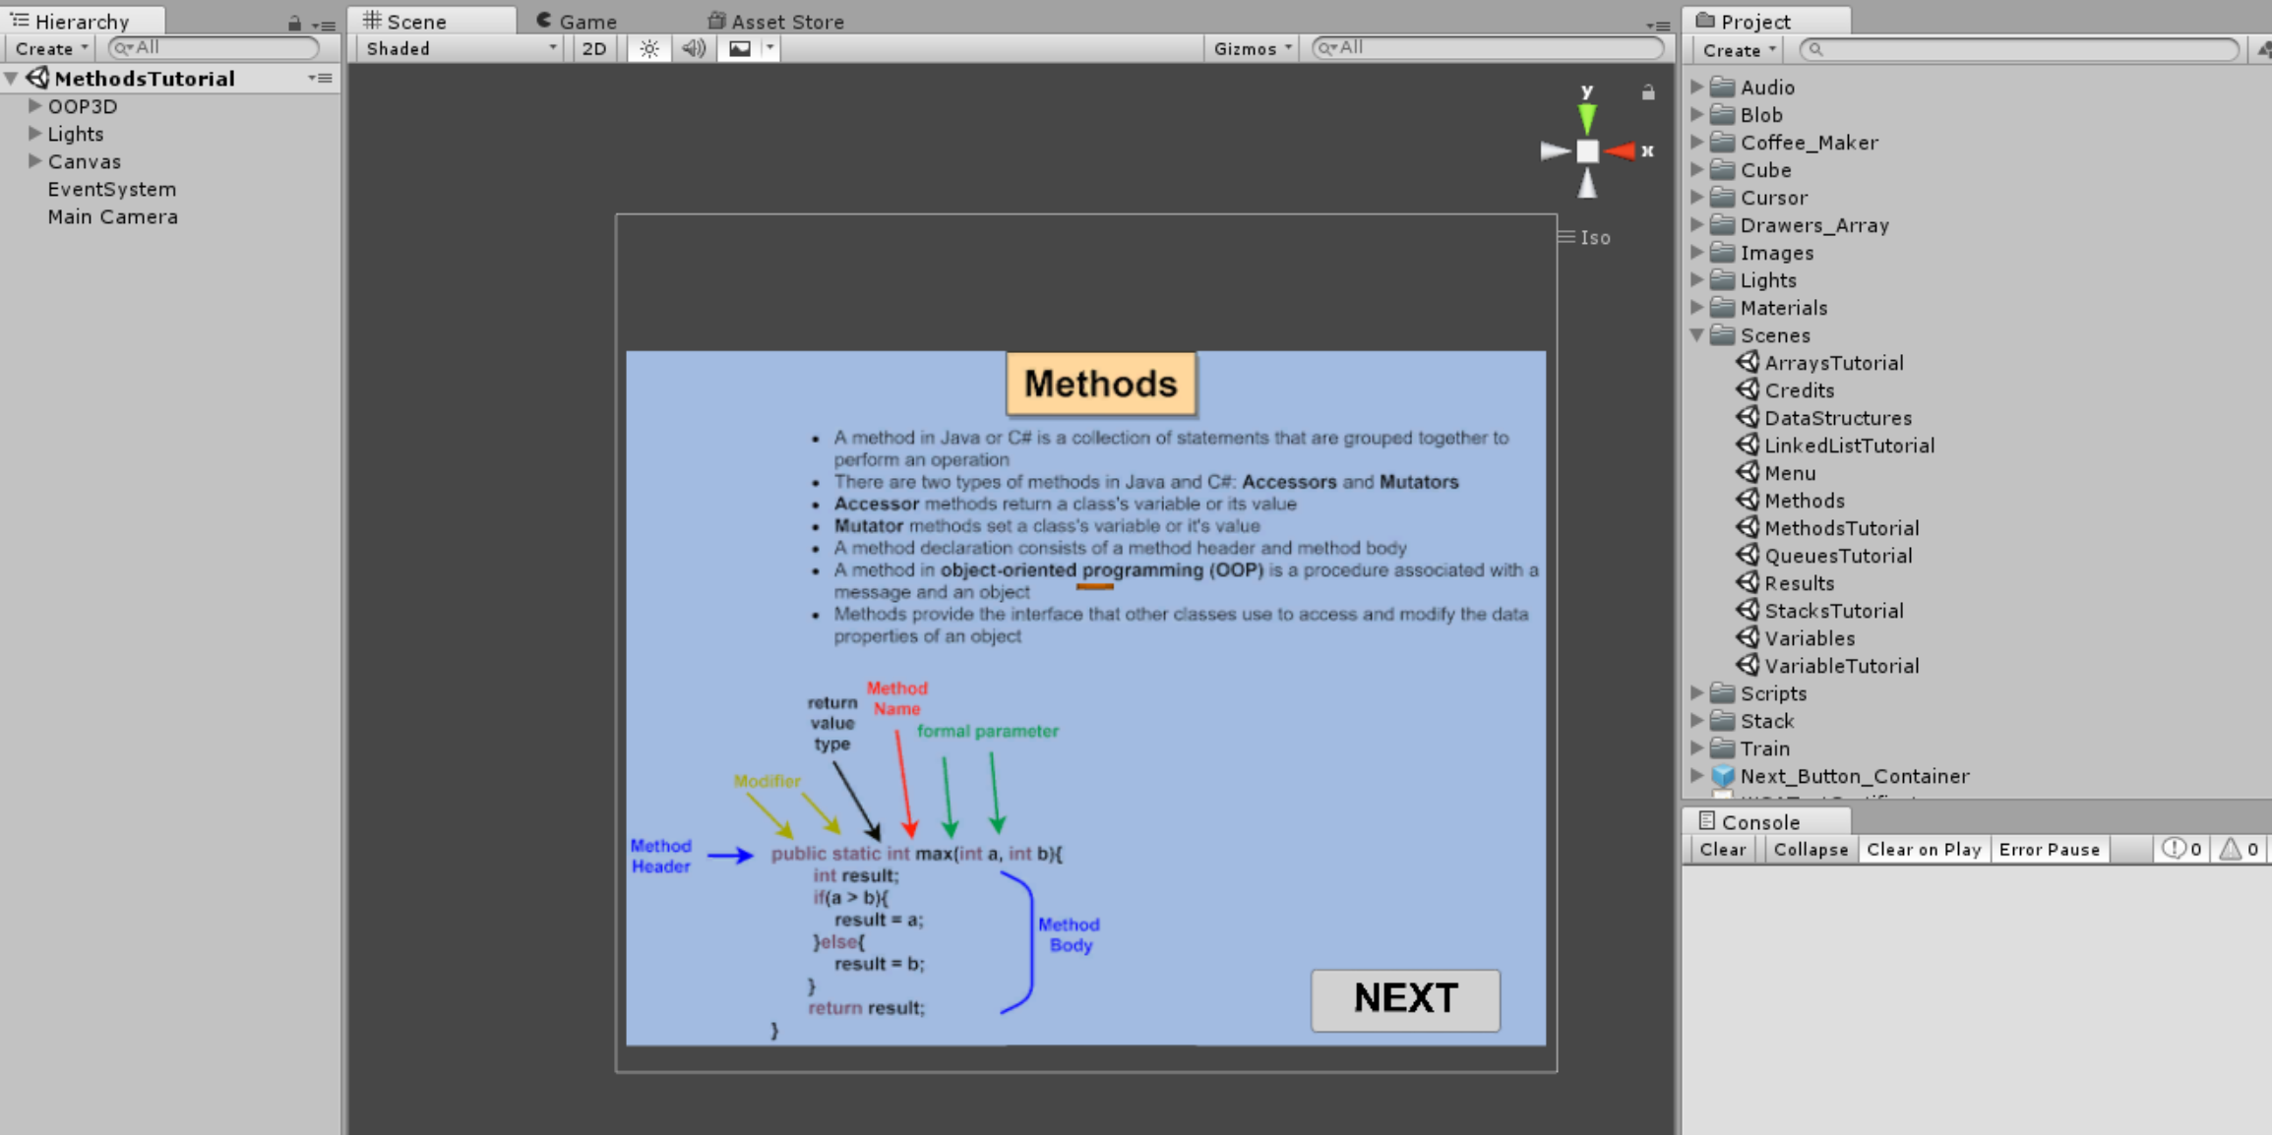

***Figure 4.*** Methods Scene Tutorials Unity

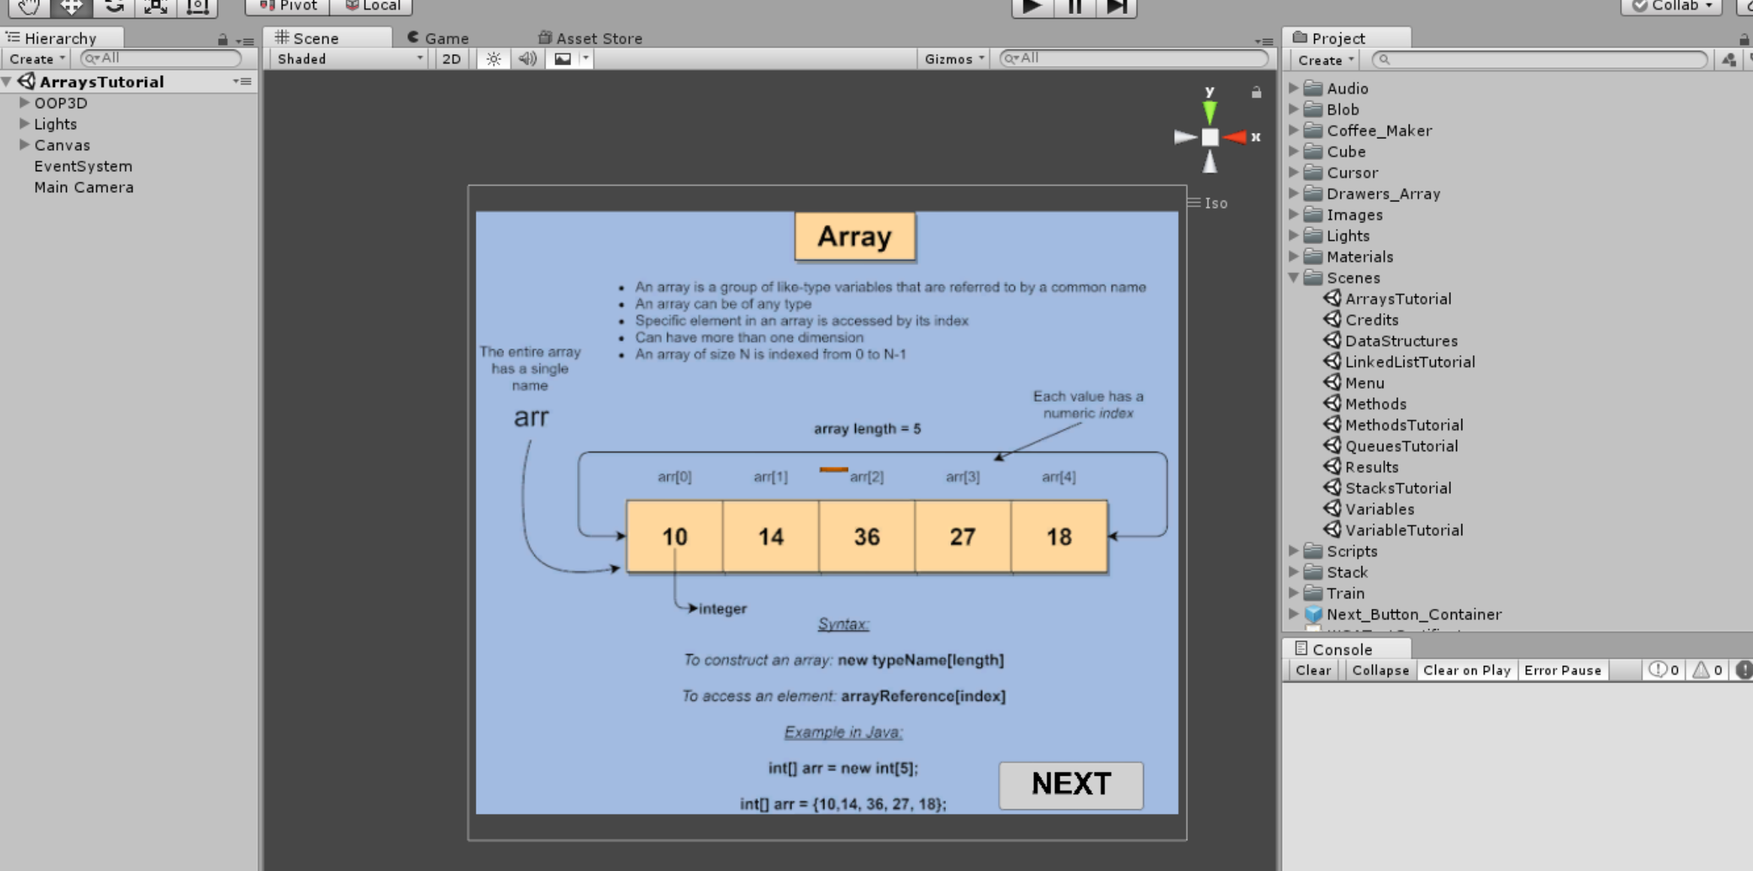

***Figure 5.*** Arrays Scene Tutorials Unity

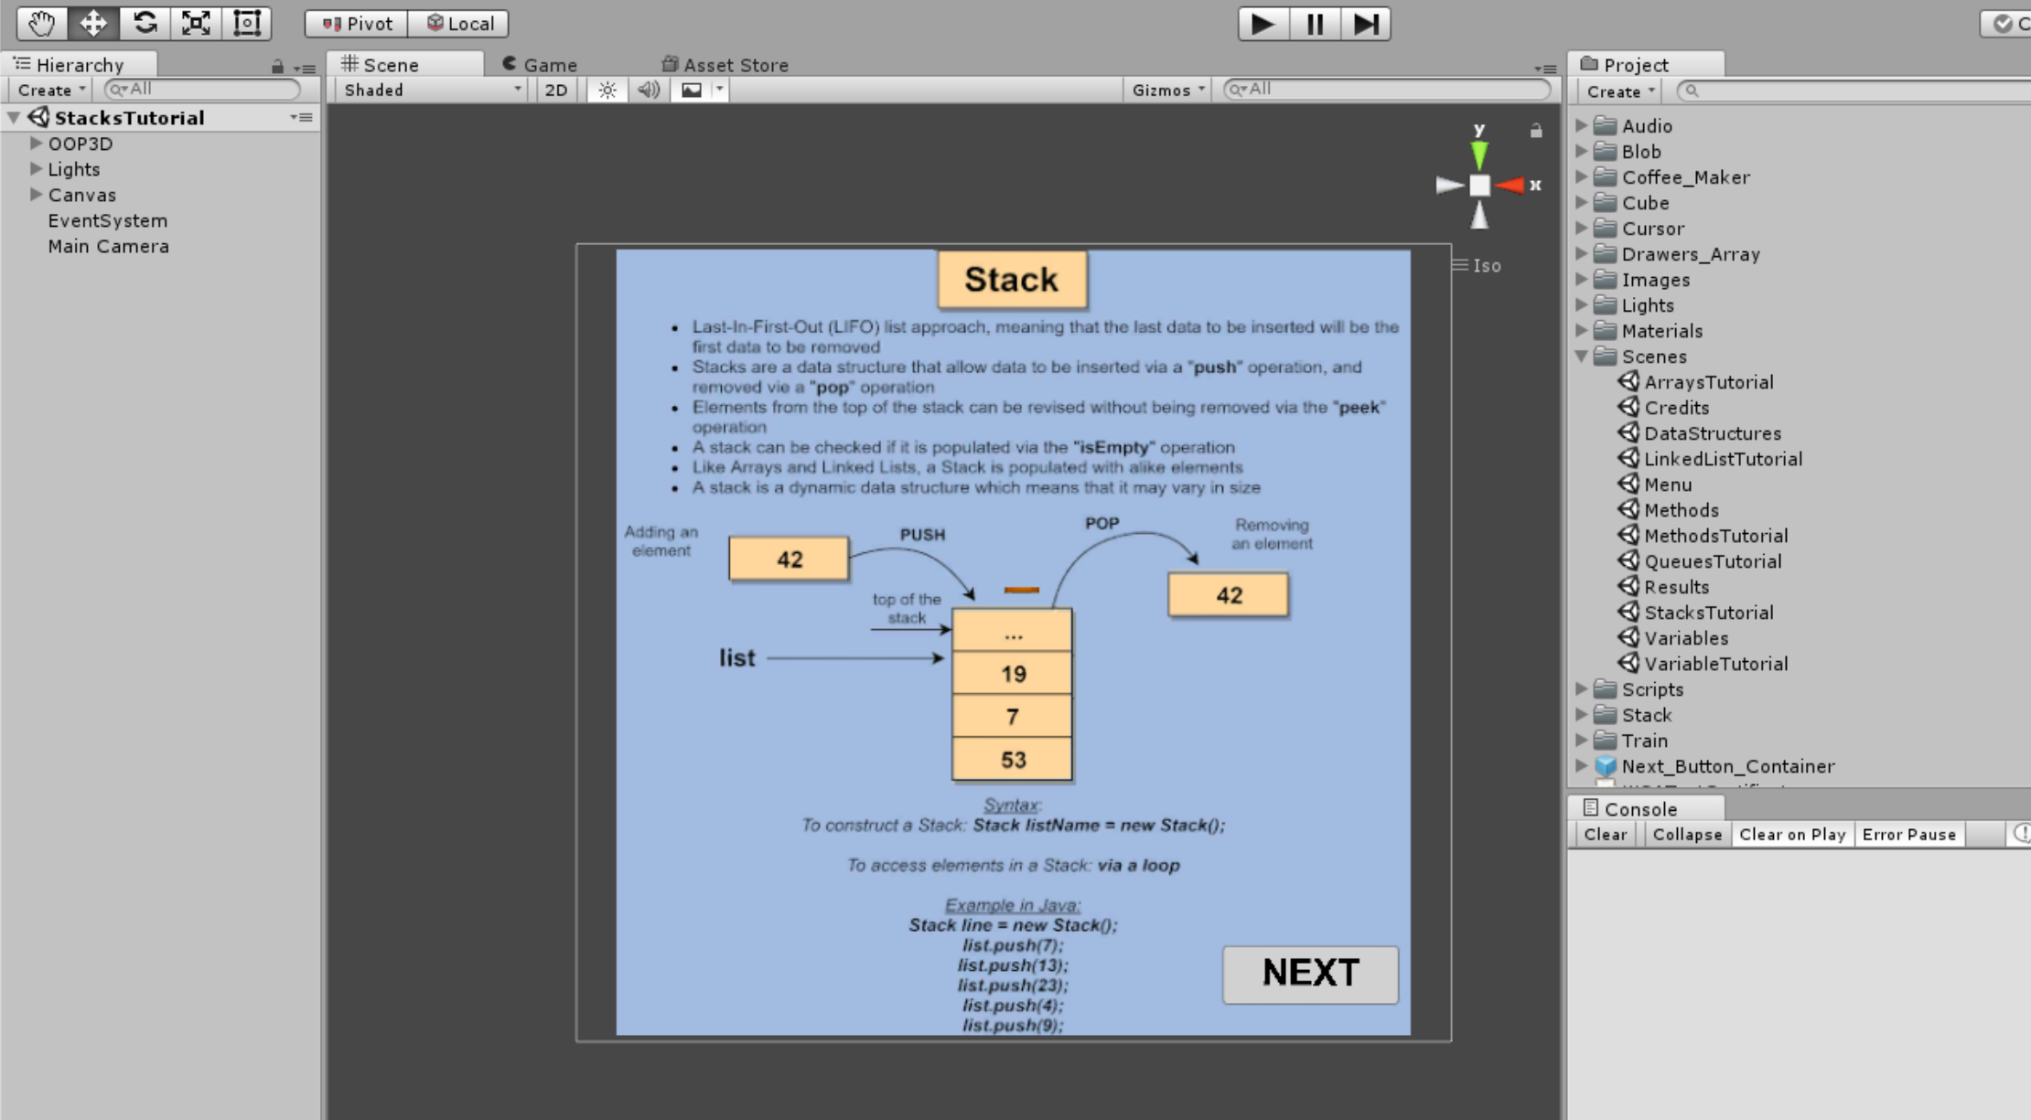

***Figure 6.*** Stack Scene Tutorials Unity

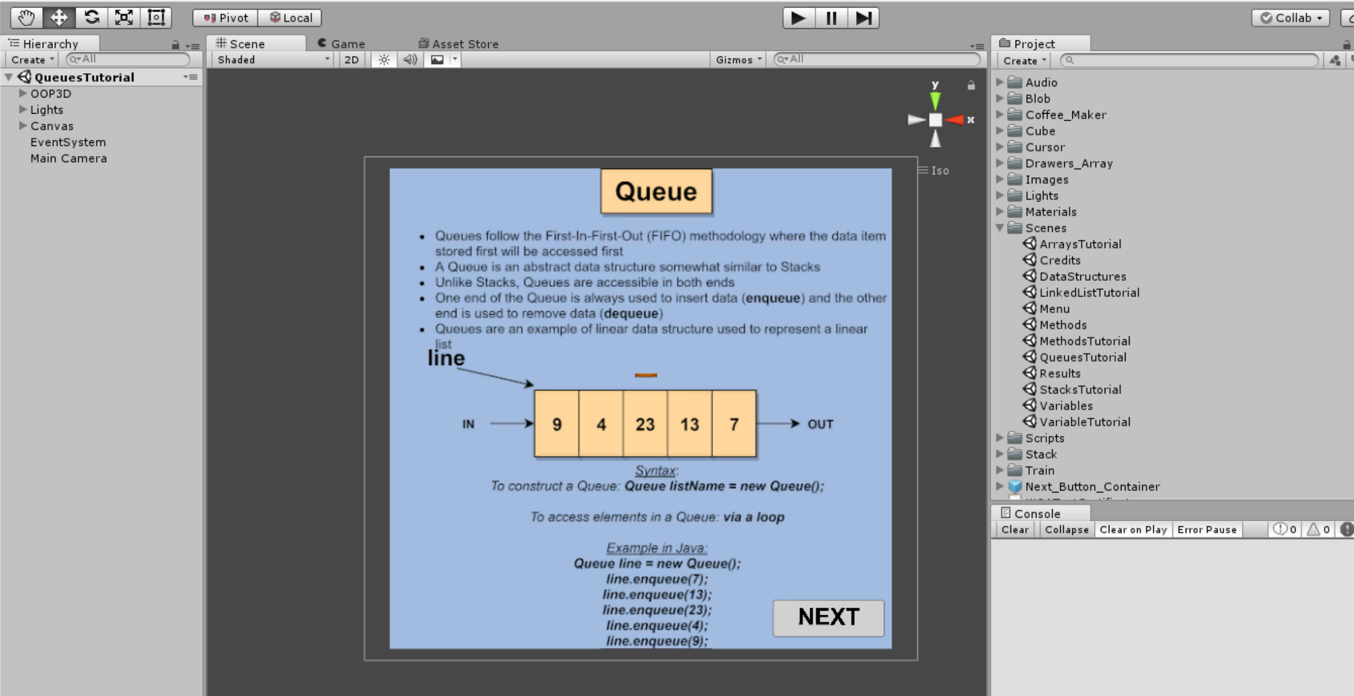

***Figure 7.*** Queues Scene Tutorials Unity

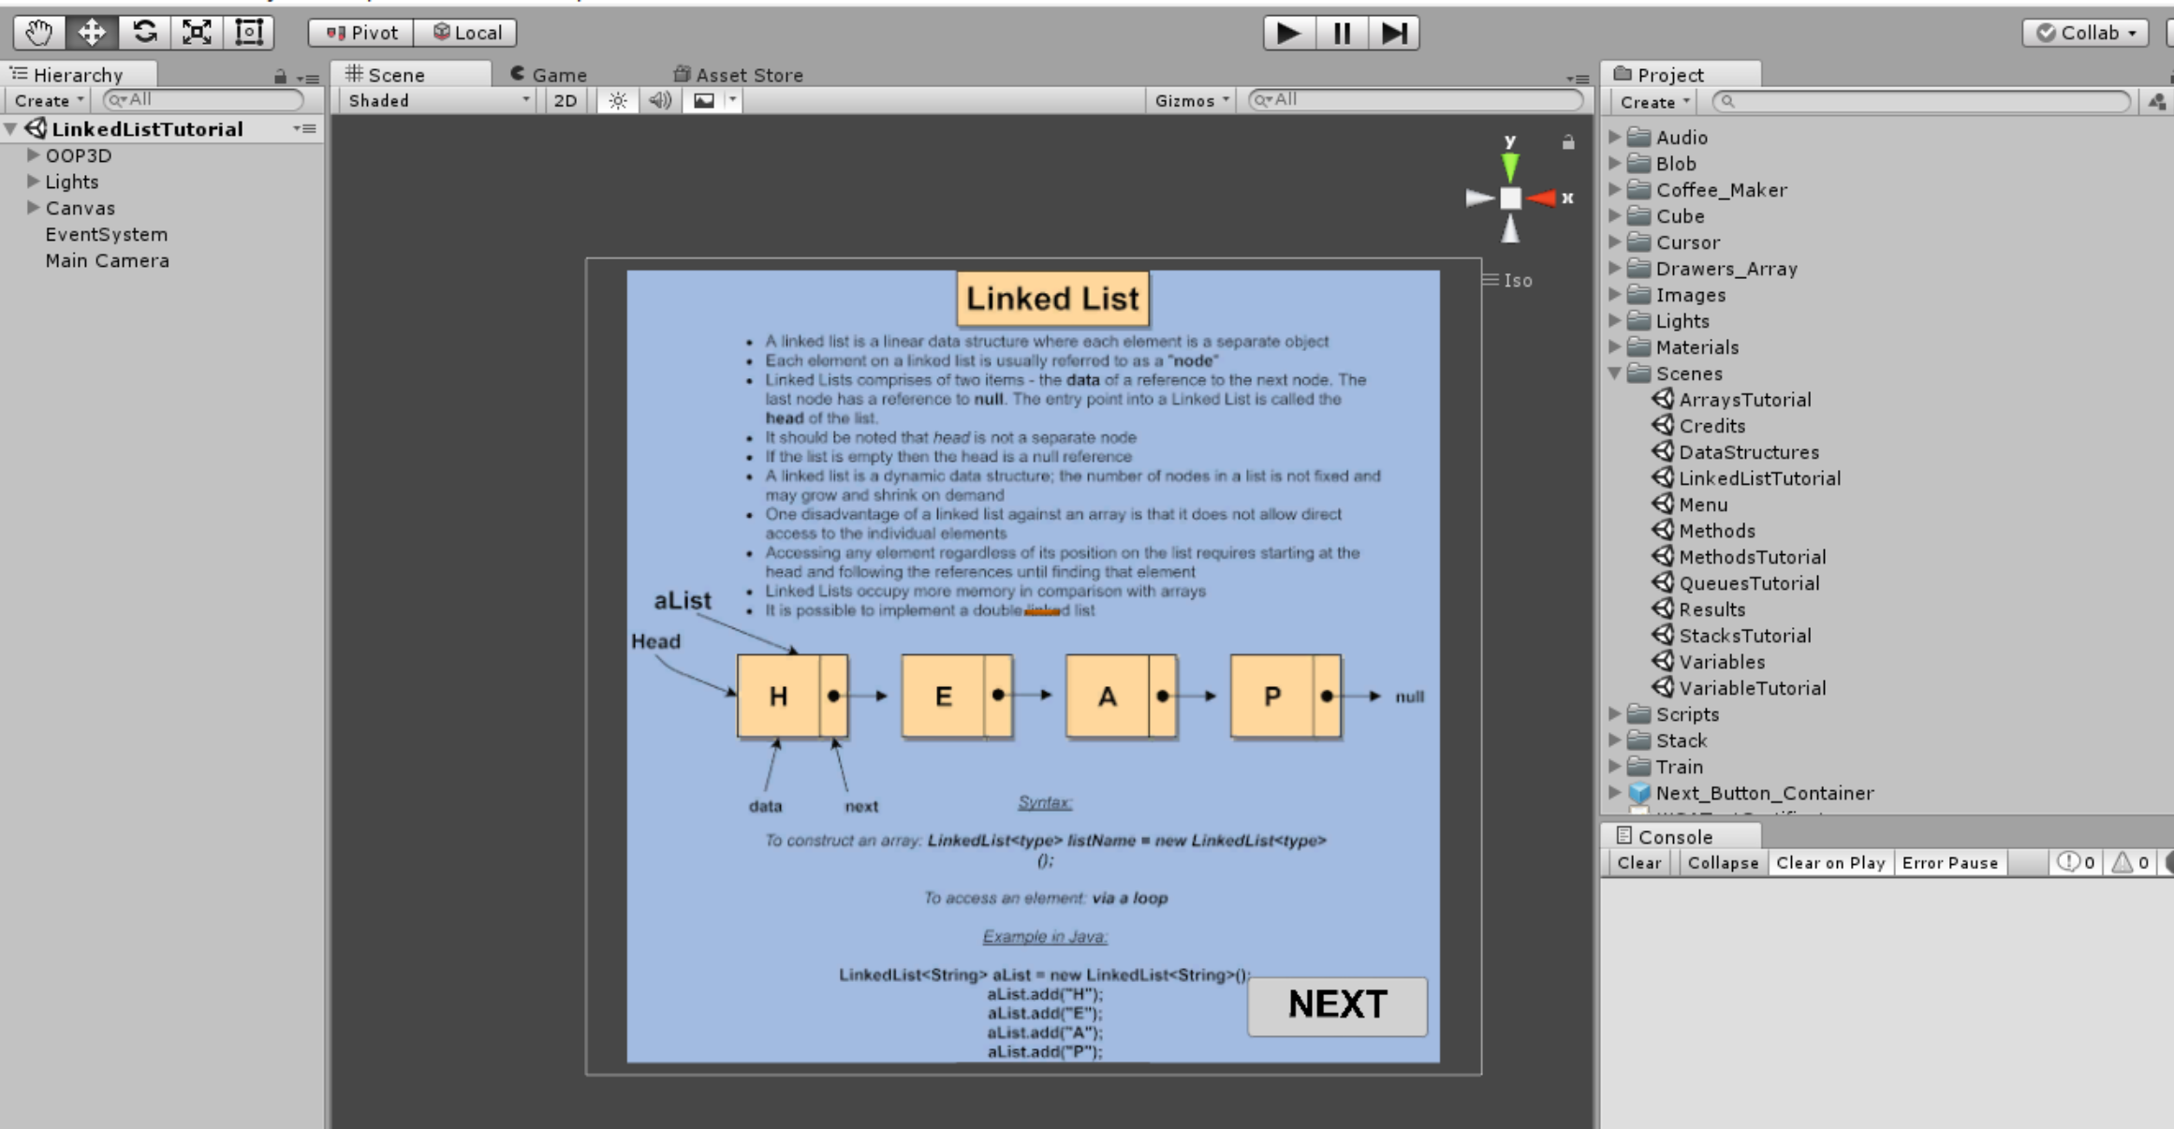

***Figure 8.*** Linked List Scene Tutorials Unity

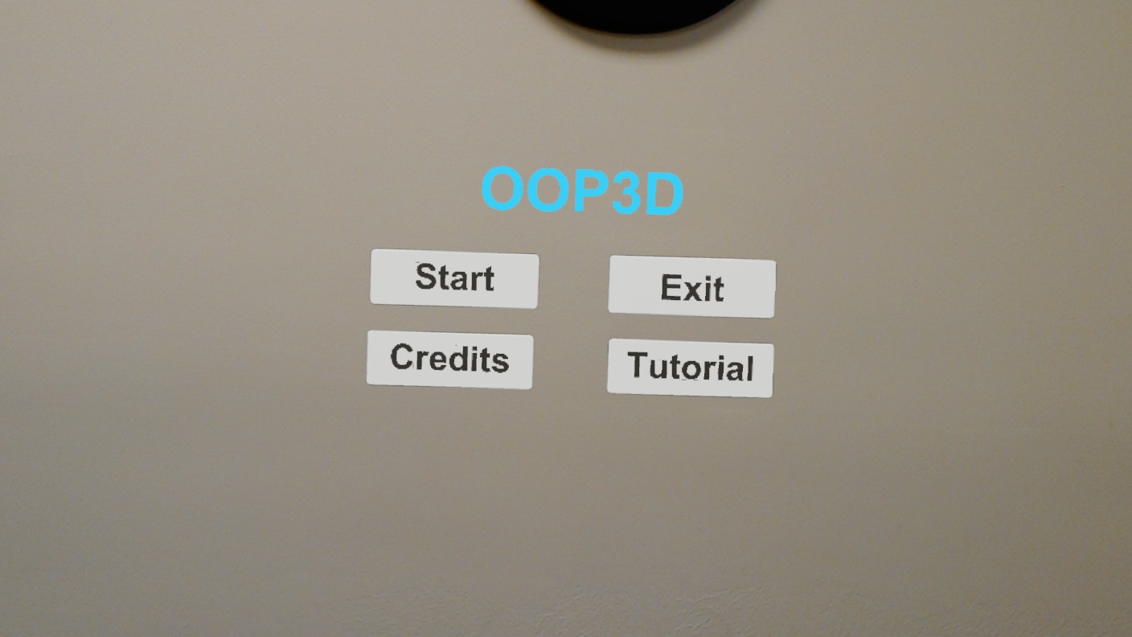

***Figure 9.*** Live Menu scene

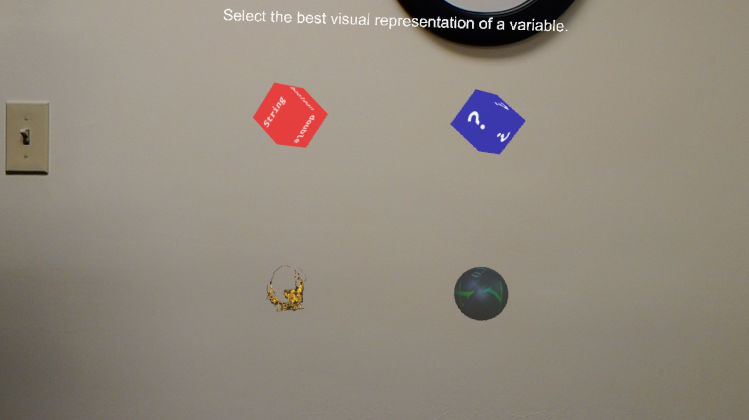

***Figure 10.*** Live Variables scene

## 

***Figure 11.*** Live Methods scene

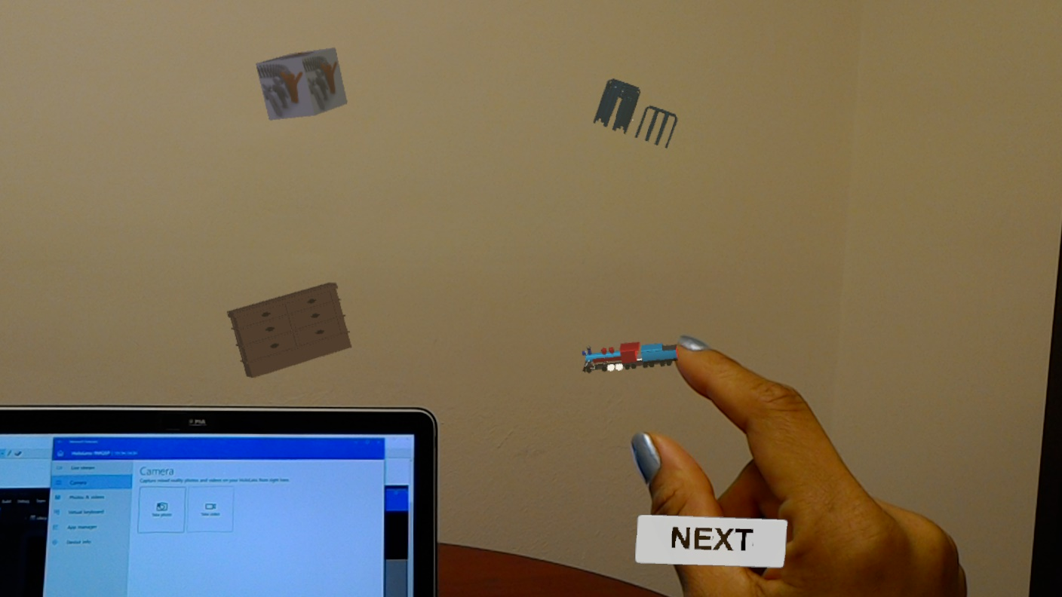

***Figure 12.*** Live Data Structures scene

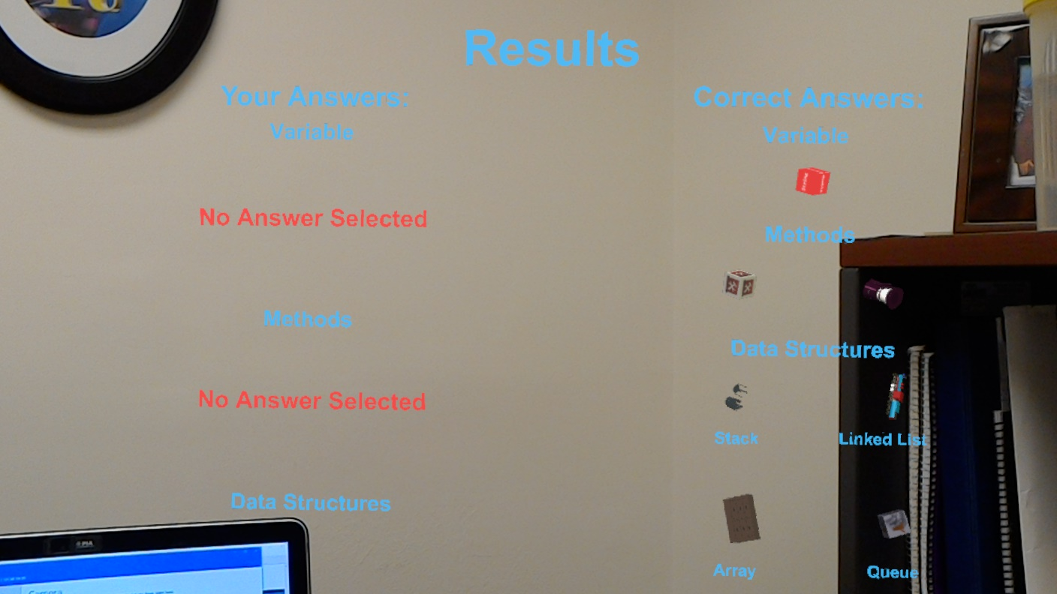

***Figure 13.*** Live Results scene

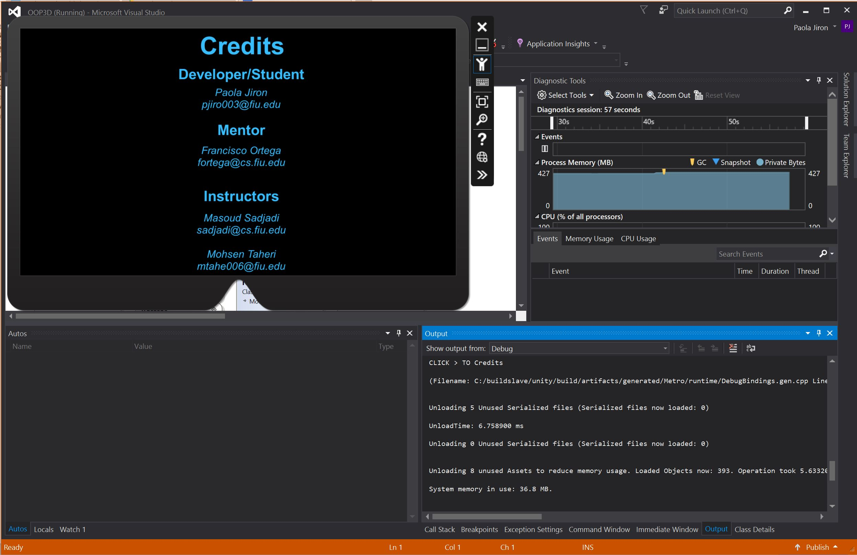

***Figure 14.*** Credits scene

## Appendix D - Sprint Review Reports

**Sprint 1 & 2 Review Meeting Minutes**

Attendees: Andres Chalela, Paola Jiron, Francisco Ortega

Start time: 5:00PM

End time: 6:00PM

After a show and tell presentation, the implementation of the following user stories were accepted by the product owners: **All.**

* User Story:**#1149 Implementation & Manipulation of 3D/Virtual Objects**

As a developer, I need to know how to implement and work with 3D objects in Unity/Visual Studio, so that I can utilize AR capabilities and have a solid foundation of how to work with virtual objects

* User Story:**#1152 Hololens User Interface/Creating Objects**

As a user I want to manipulate objects in 3D space using object oriented programming so that I get exposure to an interactive and virtual representation of programming concepts.

The following ones were rejected and moved back to the product backlog to be assigned to a future sprint at a future Spring Planning meeting.

* User Story: N/A
* How this should be reflected on the user story definition in Mingle:
  + N/A

**Sprint 3 Review Meeting Minutes**

Attendees: Andres Chalela, Paola Jiron, Francisco Ortega

Start time: 5:00PM

End time: 6:00PM

After a show and tell presentation, the implementation of the following user stories were accepted by the product owners: **All.**

* User Story:[**#1205**](https://fiu-scis-seniorproject.mingle.thoughtworks.com/projects/mult_touch_midair_and_motion_f/cards/1205) **Gaze, Gesture, and Voice Recognition**

As a user I would like to control objects with my gaze, hand gestures, or voice so that it gives me flexibility over the use of the HoloLens device in case I am either visually impaired, mute, or both (i.e. aiming for people with Disabilities)

* User Story:[**#1190**](https://fiu-scis-seniorproject.mingle.thoughtworks.com/projects/mult_touch_midair_and_motion_f/cards/1190) **(HoloLens) Implement Gaze Scripts on Unity**

As a developer, I have to be able to implement HoloLens Gaze scripts on Unity, so that Gaze input capabilities are functional within created Unity HoloLens apps.

The following ones were rejected and moved back to the product backlog to be assigned to a future sprint at a future Spring Planning meeting.

* User Story: N/A
* How this should be reflected on the user story definition in Mingle:
  + N/A

**Sprint 4 Review Meeting Minutes**

Attendees: Andres Chalela, Paola Jiron, Francisco Ortega

Start time: 5:00PM

End time: 6:00PM

After a show and tell presentation, the implementation of the following user stories were accepted by the product owners: **All.**

* User Story:[**#1**](https://fiu-scis-seniorproject.mingle.thoughtworks.com/projects/mult_touch_midair_and_motion_f/cards/1205)**154 Object Variables**

As a user I want to be able to use gestures and gaze on visual representations of variables so that I know where my gaze is to actively interact 3D environment.

* User Story:[**#1238**](https://fiu-scis-seniorproject.mingle.thoughtworks.com/projects/mult_touch_midair_and_motion_f/cards/1238) **Visualization of Variables w/in HoloLens App**

As a user, I need to be able to manipulate a variable attribute of an object, so that I can visualize and understand the purpose and functionality of variables within Object Oriented Programming.

* User Story:[**#1**](https://fiu-scis-seniorproject.mingle.thoughtworks.com/projects/mult_touch_midair_and_motion_f/cards/1190)**239 Scenes**

As a user, I would like to move through scenes as I progress through the 3D application so that I can focus on one scene at a time.

The following ones were rejected and moved back to the product backlog to be assigned to a future sprint at a future Spring Planning meeting.

* User Story: N/A
* How this should be reflected on the user story definition in Mingle:
  + N/A

**Sprint 5 Review Meeting Minutes**

Attendees: Andres Chalela, Paola Jiron, Francisco Ortega

Start time: 5:00PM

End time: 6:00PM

After a show and tell presentation, the implementation of the following user stories were accepted by the product owners: **All.**

* User Story: **#1153 Methods**

As a user I would like to see a visualization of methods and functions so that I can better understand the characteristics of methods.

* User Story: **#1155 Data Structures**

As a user I want to view visual representations of data structure concepts so that I can better understand data structure concepts.

* User Story: **#1281 Scene Transition**

As a user I would like to be able to move through scenes after making my selection so that I am progressing through the application.

* User Story: **#1304 (HoloLens) Visualization of Object Accessor/Mutator Methods**

As a user, I have to be able to be able to manipulate a holographic object’s color variable attribute, so that I can have a visualization of what object accessor/mutator methods are and how they function.

* User Story: [**#1189**](https://fiu-scis-seniorproject.mingle.thoughtworks.com/projects/mult_touch_midair_and_motion_f/cards/1189) **(HoloLens) AR/VR - Research**

As a researcher, I have to search for potential themes/ideas on AR & Education, so that I can finalize a topic and begin work on research paper.

The following ones were rejected and moved back to the product backlog to be assigned to a future sprint at a future Spring Planning meeting.

* User Story: N/A
* How this should be reflected on the user story definition in Mingle:
  + N/A

**Sprint 6 Review Meeting Minutes**

Attendees: Andres Chalela, Paola Jiron, Francisco Ortega

Start time: 5:00PM

End time: 6:00PM

After a show and tell presentation, the implementation of the following user stories were accepted by the product owners: **All.**

* User Story: **#1156 Tutorial**

As a user I would like to view a tutorial about the game so that I can see the relation between the game and actual programming concepts.

* User Story: **#1157 Feedback and Progress**

As a user I want to receive feedback so that I can track my progress in the OOP Concept AR application.

* User Story: [**#1**](https://fiu-scis-seniorproject.mingle.thoughtworks.com/projects/mult_touch_midair_and_motion_f/cards/1189)**307 AR/VR Research Paper Introduction**

As a researcher, I have to use the selected research source material to develop and finalize an introduction, so that I have a clear direction in which I plan to structure the ideas for my semester paper.

* User Story: **#1308 Finalization of AR/VR Research Paper**

As a researcher, I have to compete and finalize remaining sections of research paper, so that the final draft can be formatted properly and proof-read before the final submission deadline.

The following ones were rejected and moved back to the product backlog to be assigned to a future sprint at a future Spring Planning meeting.

* User Story: N/A
* How this should be reflected on the user story definition in Mingle:
  + N/A

## Appendix E

**User Manual**

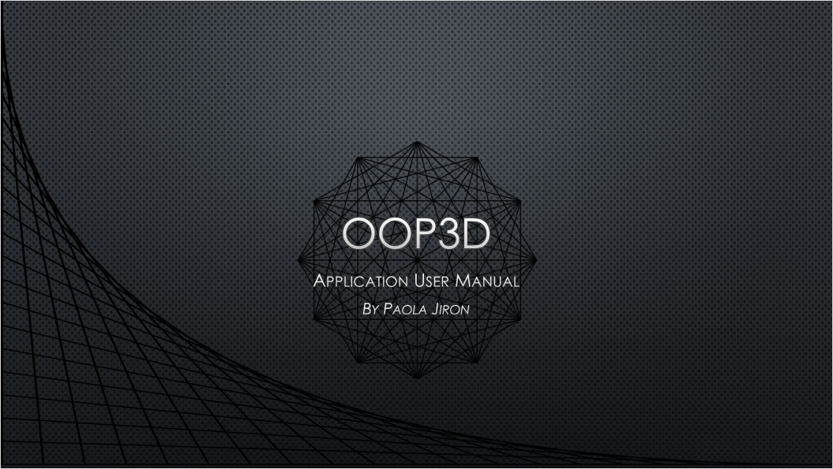

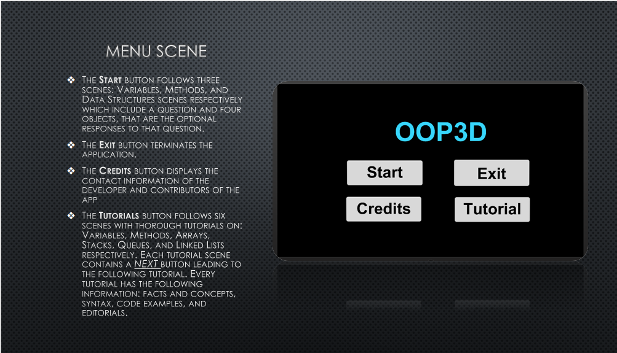

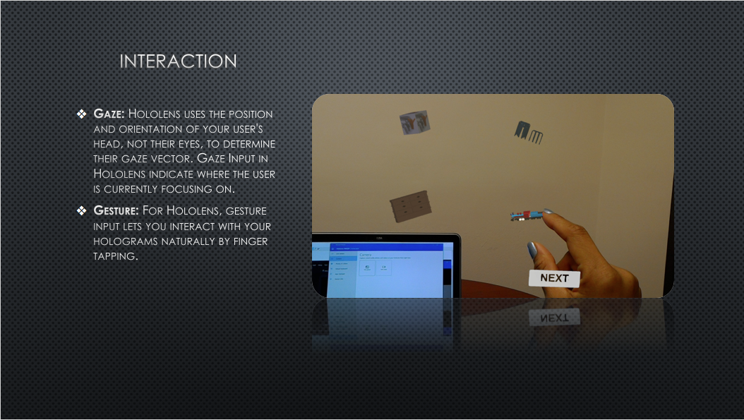

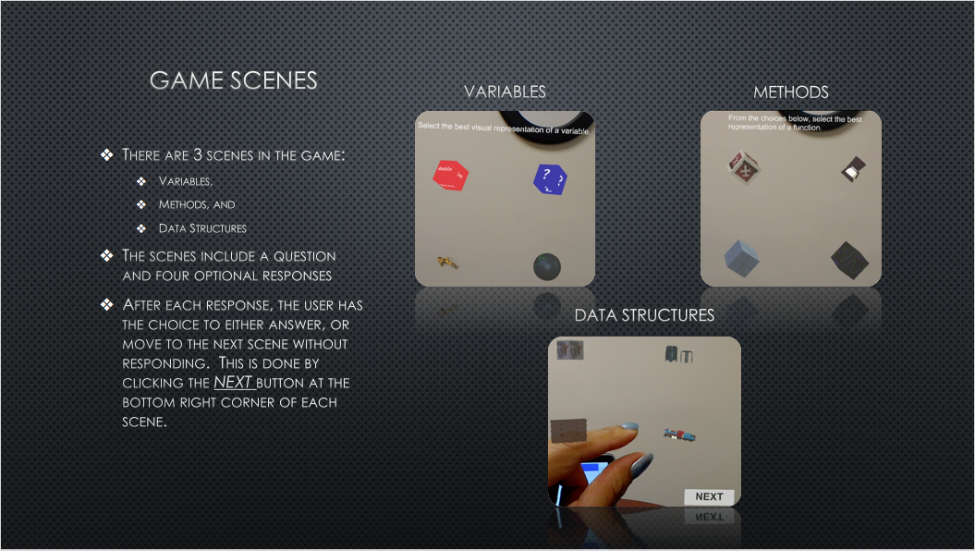

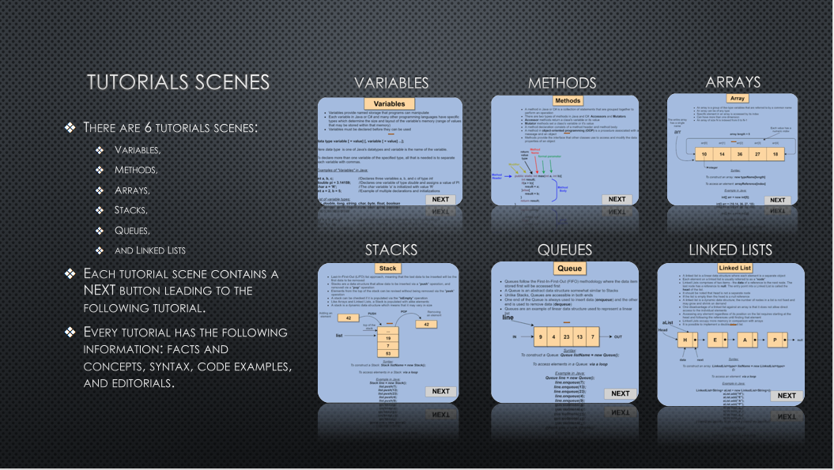

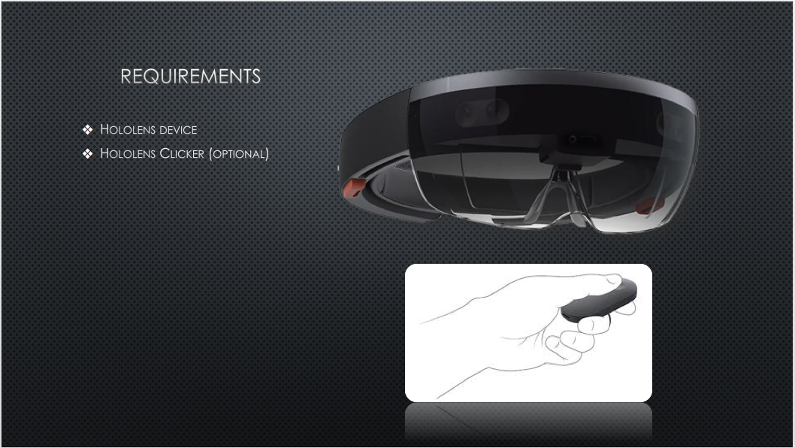

**Installation and Maintenance**



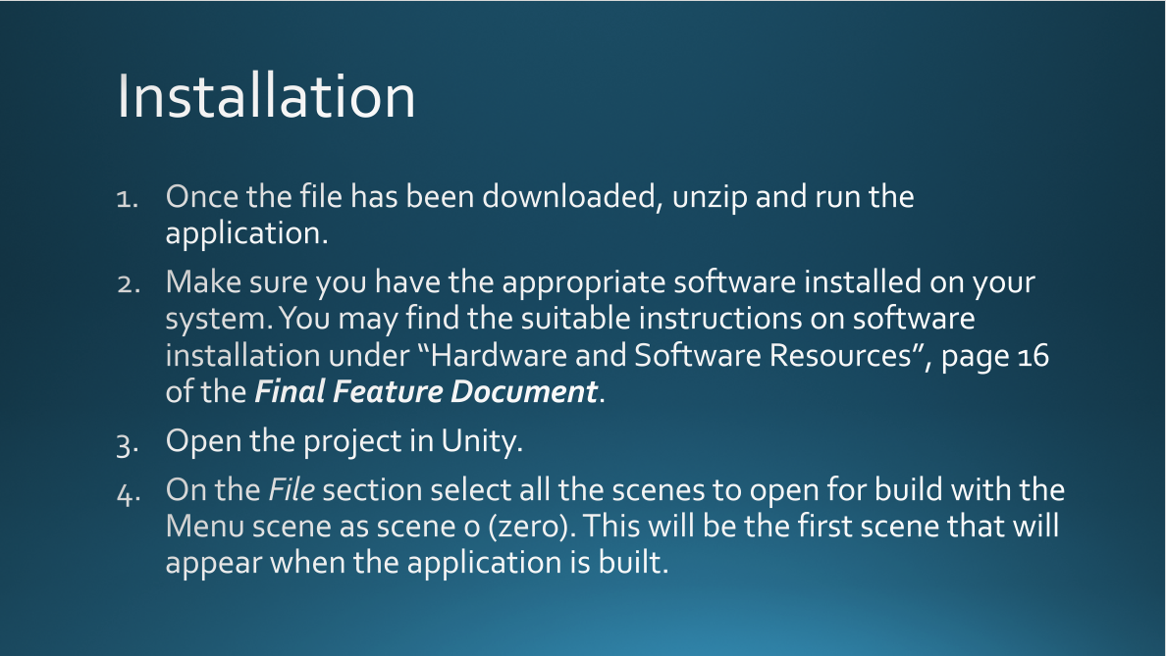

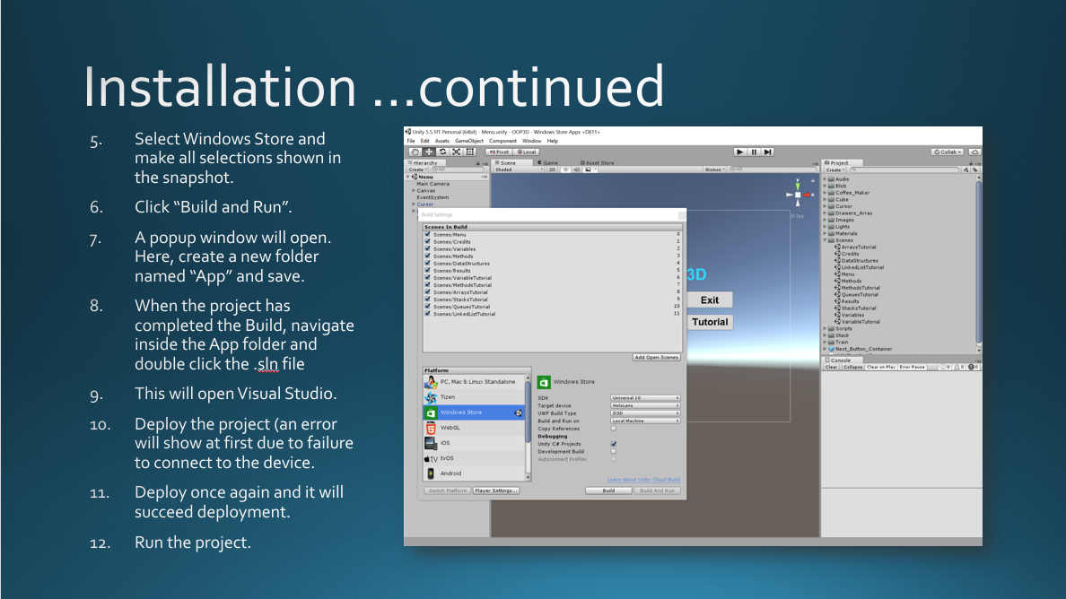

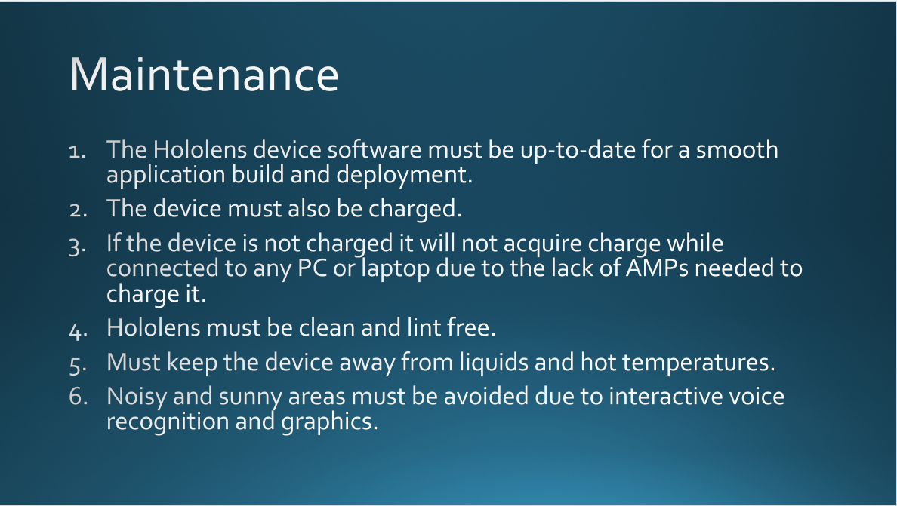

# Research

#### AR/VR Based Research

#### Beneficial Impact within Education & Learning

#### Due to the Rise of Virtual/Augmented Reality

#### Abstract

#### The utilization of technological advances in educational set up offers learners, as well as instructors with better tools.  Augmented Reality (AR) and Virtual Reality (VR) have been used in ensuring effective learning processes. The beneficial impacts of augmented and virtual reality can be classified and divided into various different sections, including discovery-based learning, object modeling, skills training, and gaming.  For successful transfer of knowledge and a positive educational experience, it is crucial to ensure effective delivery and comprehension of content. Students approve the utilization of augmented reality due to its attractiveness. The engaging technology makes learning and teaching interesting. The introduction of AR gaming makes it possible for utilization of the application at any educational level.  Therefore, it is important to warrant the adoption of augmented technologies in learning environments.

**Introduction**

#### In today’s current global environment, technology is evolving at an increasingly rapid pace. The technological advances that humans have experienced in the past decade have had an influence upon several sectors within our society. More specifically, it has impacted the perception of people within our education sectors. Traditional educational methods involved a face to face interaction, as class activities were arranged and conveyed by the tutor or teacher. Furthermore, teaching and learning material were based on static articles such as papers, journals, and textbooks. These different mediums are dated in today’s modern society, and effectively slow down the process of knowledge acquisition.

#### The mentioned traditional methods can be seen as ineffective in ensuring a dynamic classroom environment. Therefore, it is crucial for researchers and educators to improve learning and teaching experiences. Transformation caused by technological advancements has offered exciting opportunities for the creation of proper learning environments. Research shows that technology provides a platform for improved student engagement and content comprehension, which leads to improved academic results.

**The Augmented/Virtual Reality Concept**

Augmented Reality (AR) technology has the potential for a variety of practical academic applications. AR has successfully gathered attention in the educational arena, and therefore makes it a crucial component of exciting learning experiences. However, the average person does not understand its exact meaning and application. Additionally, scholars, as well as researchers, define the concept differently, but this does not affect its importance and application within the educational sector.

Tom Caudell officially formulated augmented reality in the nineteen nineties, but virtual data systems were utilized in between the 1960s and 1970s. Since 1990, AR has been utilized by large companies for training and visualizationpurposes. Furthermore, the increasing ownership of mobile devices, as well as personal computers, has been crucial in the adoption of Augmented Reality.

In recent discussions and research, the concept of AR has been given different meanings. Most people define it on the basis of a ‘Reality-Virtuality Continuum’ (Figure 1). This allows for offering a distinction between the concepts of virtual environments and AR. The virtual environment can also be regarded as Virtual Reality (VR). Virtual Reality deals with various settings where an individual is completely immersed in a synthetic environment. The primary world experienced is predominantly virtual. The virtual environment is then often augmented with real world information. It is defined as a situation that allows for dynamic overlaying of real world context into a sensitive virtual information (SVI).

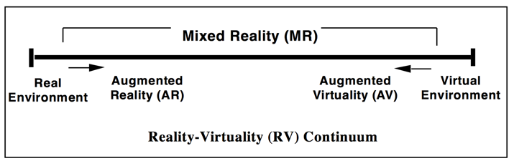

*Figure 1: Reality-Virtuality Continuum*

**Benefits of Augmented and Virtual Reality in Education and Learning**

AR can be implemented in a learning environment in a variety of ways. These different methods of implementation are often referred to as ‘the five directions’ of augmented reality in a learning and teaching set up, and they assist in the improvement of learning outcomes. Additionally, these approaches are essential in achieving consistency in knowledge transfer and acquisition among learners. Developing a teaching strategy that positively impacts the majority of student learning is critical. Augmented Reality can be an invaluable tool for improving learning effectiveness. Additionally, teaching and learning with AR can help bridge the grade gap between students that have difficulty with grasping course material and students who perform well without additional support.

**Discovery-Based Learning**

AR can assist in connecting knowledge with actions, as well as choices. Having this connection is an essential principle of achieving success in learning. Creating linkage between practice and education is important in fields such as construction and health. It is important to note that most engineering learning activities still depend on traditional methods. Generating a curriculum that is responsive to the needs of the current modern population enables easier and better learning. Social and technical skills, such as decision-making, critical skills, and leadership, are essential in today’s learning environment. Moreover, competency in digital applications often leads to effective learning outcomes.

Embracing new modern technologies makes learning and teaching easy and flexible. It is common that students with a high potential of performing well in STEM fields often switch to non-scientific career paths. This switch can be attributed to the teaching techniques used in the STEM fields, thus highlighting the need for the adoption of new learning methods. The utilization of advanced technological methods in academic situations has recently received more attention and has been gaining momentum. AR and VR can potentially assist in the introduction of electronic field trips in various courses. Field work is a critical component of learning in all areas, and VR can effectively introduce learners to dynamic real world scenarios that will effectively prepare them for real-world situations. Augmented and Virtual Reality offer an opportunity for experimentation with different teaching methods. It breaks the class monotony in effective ways, and due to the increased role of computer assisted programs, virtual field trips have played a major role in student engagement.

The expansion of discovery based learning has been boosted by the introduction of computer applications in augmented and virtual reality. This expansion has improved cooperation and engagement among students. Through virtual reality, students can see the development of ideas in a three-dimensional environment, which encourages teamwork and proper knowledge dissemination in various fields.

**Objects Modeling**

AR and VR object modeling applications allow students to receive quick visual feedbacks on how a given item looks and behaves in a variety of settings. Virtual objects can be investigated for their interactions with other elements, and furthermore, their physical characteristics can also be studied. The utilization of AR has been key in the study of health sciences. The study of biological concepts requires an understanding of three-dimensional models. Therefore, the integration of computer informatics and biological domains is essential in helping learners understand complex health systems and concepts.

In the past, proteins were modeled through fixed positions of atoms on a given backbone template. These involved substantial computational resources, as well as complex calculations. The rising utilization of computer programs has improved creation and comprehension of biological structures. In the learning of models, AR adds contextual information, which has the potential to improve molecular biology. It makes it possible for learners to understand subjects such as inorganic chemistry. AR assists in the viewing of various structures through a collaborative system.

Augmented Reality supported learning offers an opportunity for users to view their bodies and effects when using the application. Additionally, the modeling of objects makes education interesting due to the combination of experimental and experiential properties. Students often approve the utilization of AR for its attractiveness. Furthermore, the application of AR technology can assist in overcoming limitations faced by learners in understanding hard to grasp mechanisms. For example, many students have become interested in bioinformatics due to the introduction of AR that makes learning and teaching interesting.

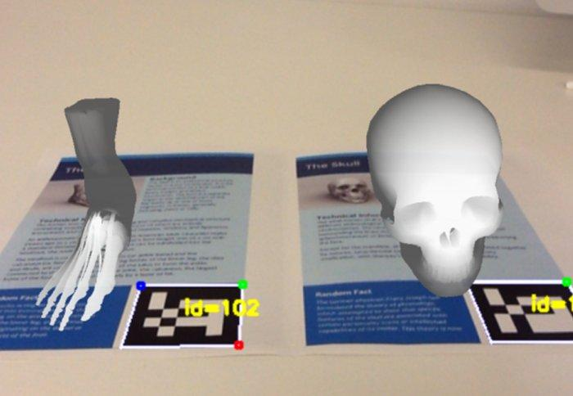

*Figure 2: Object Modeling in Medicine/Health*

**Books on Augmented Reality**

AR books provide students with three-dimensional (3D) presentations, as well as interactive learning experiences. These books are augmented through technological devices and platforms, including special glasses or headsets. AR provides a realistic experience because of its multi-sensory three-dimensional transitional interfaces and models. These features allow users to interact with virtual and real worlds seamlessly. Also, AR interacts with various objects providing real-time information. This is done through the detection of situation and location in acontext via the use of multi-sensors and cameras. AR creates an interactive environment incorporating simulation, 3D, and animation.

AR books are physical paper books that have multimedia and voice elements incorporated via AR elements. These books improve overall realism and familiarity to learners. The realism assists students by allowing them to interact with a platform that integrates the real-world environment. Augmented Reality books are often attractive, resulting in immersion and motivation. Additionally, the books facilitate a constructive, active, intentional, practical, as well as collaborating learning. AR also improves the understanding of complex calculations and concepts. This engaging and dynamic interaction between student and learning platform, improves the attitude of students towards learning, which often leads to a positive impact in achieving high grades.

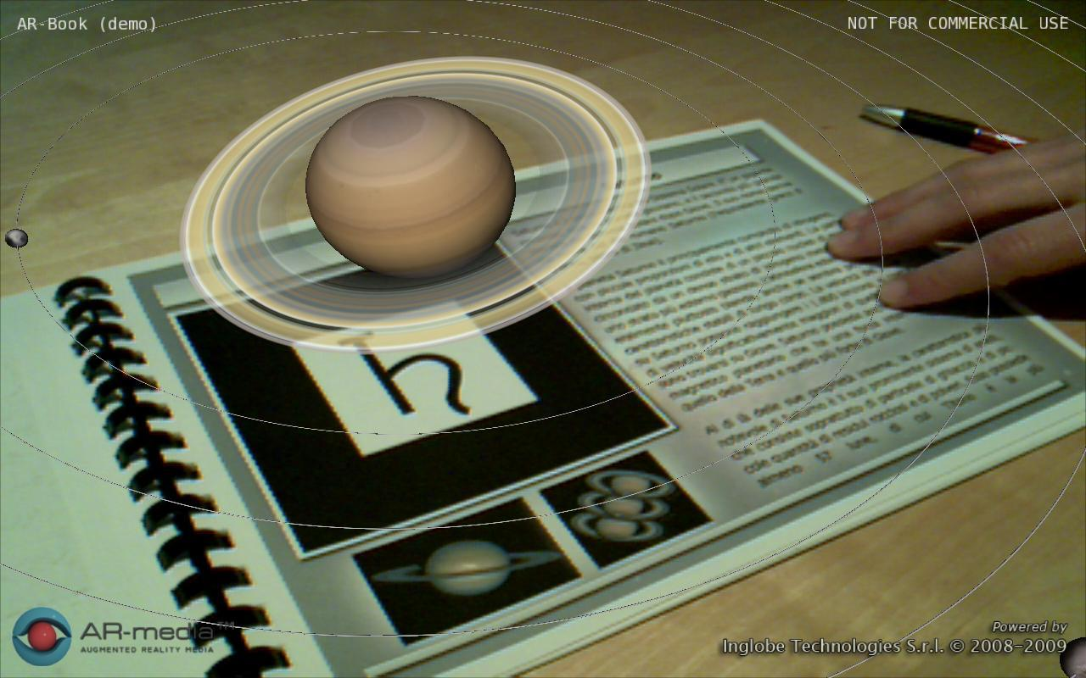

*Figure 3: AR Book Example*

**Skill Training**

AR applications can support and have a positive impact on the training of skills in a variety of different industries. In today’s environment, AR applications that target skill development are often utilized in the aviation industry for airplane maintenance. This training activity involves the display of steps, tools identification, and inclusion of textual instructions. The training is commonly done through head mounted displays.

AR is also essential in industrial training, involving maintenance and assembly of large machinery. Cameras are utilized in the capture of activities in a large-scale environment. Videos document complex maintenance and assembly workflows. Learners have the ability to use mobile AR tools in machine inspection. Any problem that occurs during inspection and maintenance can be easily detected and corrected. The advantage of utilizing this type of training is that it allows learners to interact with real-time objects. Therefore, trainees can connect real task and training, which further reinforces the retention of knowledge.

The AR skill training approach also provides a trainer with real-time feedback during task performance as the learner interacts with real and virtual environments. Virtual objects offer supplementary information about a given task, as well as its performance. A learner can access real environment and training materials without utilizing user manuals, thus improving productivity. The monitoring and evaluation of students’ performance assists tutors in responding to performances of various students. The learning approach enables communication and presentation of correction within a learning environment, allowing users to detect, correct, and learn from any potential mistakes.

**Augmented Reality in Gaming**

In the contemporary education sector, trainers have realized the power of AR Gaming in ensuring effective delivery and comprehension of contents. AR technologies allow for the development of games that can occur in the real world. These games are often executed in a physical environment that is augmented with virtual data, and they offer powerful ways of ensuring proper teaching and learning. AR games offer a highly visual, as well as interactive learning tactic, that has been utilized in simulation training. The gaming approach allows the integration of virtual and real environments in education, ensuring the acceleration and maximization of knowledge transfer and acquisition.

In most cases, games for educational purposes are designed to be tackled by groups. This leads to social benefits for learners. These AR games often deliver important global messages and therefore are often valuable in the sensitization of students. For instance, ‘The World Without Oil’ is a game presented by Independent Television Service (ITS). It sensitizes users on the importance of conserving non-renewable energy sources. These games also offer cognitive challenges to learners. A novel, as well as realistic problem, is often posted for a user to solve. When addressing these issues, students are required to apply their academic knowledge. This is essential in the development of new ideas. Therefore, augmented gaming is important to all educational levels, as it provides learners with an adequate time for likeable interactions and knowledge acquisition.

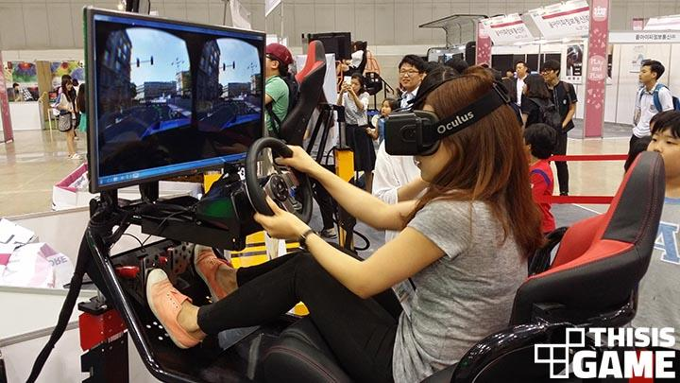

*Figure 4: Young Student Playing VR Driving Game*

# *References*

# Application Development References

[1] "Install the tools." *Install the tools*. N.p., n.d. Web. 20 Feb. 2017. <https://developer.microsoft.com/en-us/windows/holographic/install_the_tools>.

[2] "Roll-a-ball tutorial." *Unity*. N.p., n.d. Web. 20 Feb. 2017. <https://unity3d.com/learn/tutorials/projects/roll-ball-tutorial>.

[3] "Holograms 101E." *Holograms 101E*. N.p., n.d. Web. 20 Feb. 2017. <https://developer.microsoft.com/en-us/windows/holographic/holograms_101e>.

[4] "Academy." *Academy*. N.p., n.d. Web. 27 Feb. 2017. <https://developer.microsoft.com/en-us/windows/holographic/academy>.

[5] "Unity development overview." *Microsoft Developer.* Web. 27 Feb. 2017. <http://developer.microsoft.com/en-us/windows/holographic/unity_development_overview>.

[6] "Creating a scene selection menu." *Unity*. N.p., n.d. Web. 12 Mar. 2017. <https://unity3d.com/learn/tutorials/modules/beginner/live-training-archive/creating-a-scene-menu?playlist=17111>.

[7] "Creating a scene selection menu." *Unity*. N.p., n.d. Web. 12 Mar. 2017. <https://unity3d.com/learn/tutorials/modules/beginner/live-training-archive/creating-a-scene-menu>.

[8] "Creating Collectable Objects." *Unity*. N.p., n.d. Web. 12 Mar. 2017. <https://unity3d.com/learn/tutorials/projects/roll-ball-tutorial/creating-collectable-objects?playlist=17141>.

[9] "How Can I display Hello World Text On my Hologram app?" *Hololens Developer Community*. N.p., n.d. Web. 12 Mar. 2017. <https://forums.hololens.com/discussion/comment/3861#Comment_3861>.

[10] "Coding for the HoloLens with Unity 5 – Part #7 – Creating a basic HUD." *Jeremy Lindsay*. N.p., 28 Aug. 2016. Web. 12 Mar. 2017. <https://jeremylindsayni.wordpress.com/2016/08/28/coding-for-the-hololens-with-unity-5-part-7-creating-a-basic-hud/>.

[11] "Main Page." *Wikipedia*. Wikimedia Foundation, 14 Apr. 2017. Web. 15 Apr. 2017. <https://en.wikipedia.org/wiki/Main_Page>.

[12] ["Microsoft to ship Windows Server 2008, over time, in eight flavors"](http://www.zdnet.com/blog/microsoft/microsoft-to-ship-windows-server-2008-over-time-in-eight-flavors/935). Retrieved 2007-11-13. Web. 15 April. 2017.

[13] [Jump up^](https://en.wikipedia.org/wiki/Hyper-V#cite_ref-2) Paul Thurrott. "Windows Server Virtualization Preview". Retrieved 2007-09-25.

[14] "Coding for the HoloLens with Unity 5 – Part #7 – Creating a basic HUD." *Jeremy Lindsay*. N.p., 28 Aug. 2016. Web. 12 Mar. 2017. <https://jeremylindsayni.wordpress.com/2016/08/28/coding-for-the-hololens-with-unity-5-part-7-creating-a-basic-hud/>.

[15] "Application.LoadLevel obsolete but SceneManager.LoadScene Doesn't work." *Application.LoadLevel obsolete but SceneManager.LoadScene Doesn't work - Unity Answers*. N.p., n.d. Web. 15 Apr. 2017. <http://answers.unity3d.com/questions/1113197/applicationloadlevel-obsolete-but-scenemanagerload.html>.

[16] Dixit, Atharv. "Microsoft Hololens : A New Aeon of Blended Reality." *GeeksNation*. GeeksNation, 03 Oct. 2016. Web. 15 Apr. 2017. <http://geeksnation.org/microsoft-hololens-new-aeon-blended-reality/>.

# Research References

[1] J. Cooperstock, "The Classroom of the Future: Enhancing Education through Augmented Reality," 2001. [Online]. Available: http://srl.mcgill.ca/publications/2001-HCI.pdf. [Accessed 10 April 2017].

[2] D. Nincarean, B. A. Mohamad, A. N. D. Halim and A. H. Rahman, "Mobile Augmented Reality: the potential for education," Elsevier Journal, vol. 103, pp. 657-664, 2013.

[3] P. Chen, X. Liu, W. Cheng and R. Huang, A review of using Augmented Reality in Education, Singapore: Springer Science+Business Media, 2017.

[4] O. ÇalÕúkan, "Virtual field trips in the education of earth and environmental sciences," Procedia Social and Behavioral Sciences, vol. 15, no. 11, pp. 3239-3243, 2011.

[5] A. H. Behzadan and V. R. Kamat, "Enabling discovery‐based learning in construction using telepresent augmented reality," Elsevier Journal, vol. 33, pp. 3-10, 2013.

[6] N. Lau, A. Oxley and. M. Nayan, "An Augmented Reality Tool to Aid Understanding of Protein Loop Configuration," in International Conference on Computer & Information Science, Shanghai, China, 2012.

[7] G. Ivanova, Y. Aliev and A. Ivanov, "Augmented Reality Textbook for Future Blended Education," in International Conference on e-Learning, La Laguna, 2014.

[8] S. Webel, U. Bockholt, T. Engelke and M. Olbrich, "Augmented Reality Training for Assembly and Maintenance Skills," in BIO Web of Conferences, Munich, 2011.

[9] M. Bergamasco, B. Bardy, and D. Gopher, Skill Training in Multimodal Virtual Environments, Boca Raton, FL: CRC Press, 2012.

[10] Information Resources Management Association, Gaming, and Simulations: Concepts, Methodologies, Tools, and Applications: Concepts, Methodologies, Tools, and Applications., Hershey, PA: IGI Global, 2011.